Knowledge Organiser
Autumn Term 2 Set 2 Year 10
Topic | Self-Assessment | Independent Learning and  homework tasks
Topic | Self-Assessment | MyMaths | CorbettMaths.com
Forming linear expressions (4) |  | N/A | Video 115
Convert fractions, decimals & percentages (3/4) |  | Number, Percentages, Frac Dec Perc 2 | FDP  Videos 121 to 131
Converting recurring decimals to fractions (7) |  | Number, Decimals, Fractions, Recurring Decimals 2 | Video 96
Finding percentage of a quantity and one quantity as a percentage of another (3) |  | Number, Percentages, Percentage of Amounts 2 | Video 50 - 52
Percentage increase and decrease (4) |  | Number, Percentages, Percentage Change 1 | Percentage Change video 233
Reverse Percentages (6) |  | Number, Percentages, Percentage Change 2 | Percentages: Reverse video 240
Compound interest (5) |  | Number, Percentages, Percentage Change 2 | Percentages: Compound Interest video 236
Transformations (4); reflection, rotation, translation |  | Shape, Transformations, …… | Video 272 – 275, 326
Enlarge shapes using positive and negative scales factors (4/6) |  | Shape, Transformations, Enlarging Shapes | Video 104 - 109
Understanding and calculating with ratios and proportion (4/5) |  | GCSE 1-9, Ratio & Proportion – Proportion, Best Buy & Unitary | Video 269, 271a – d, 255a
Be able to share in a given ratio (4/5) |  | GCSE 1-9, Ratio & Proportion – Ratio, Ratio Dividing 1 & 2 | Video 269, 271a – d, 255a

Stretch and Challenge:
- Practise UKMT Intermediate Maths Challenge Past papers on:
https://www.ukmt.org.uk/competitions/solo/intermediate-mathematical-challenge/archive
- Set up an account on parallel.org.uk website, using your school email address and use teacher code “ha52kh”
- Attend Puzzle Club one lunch time each week

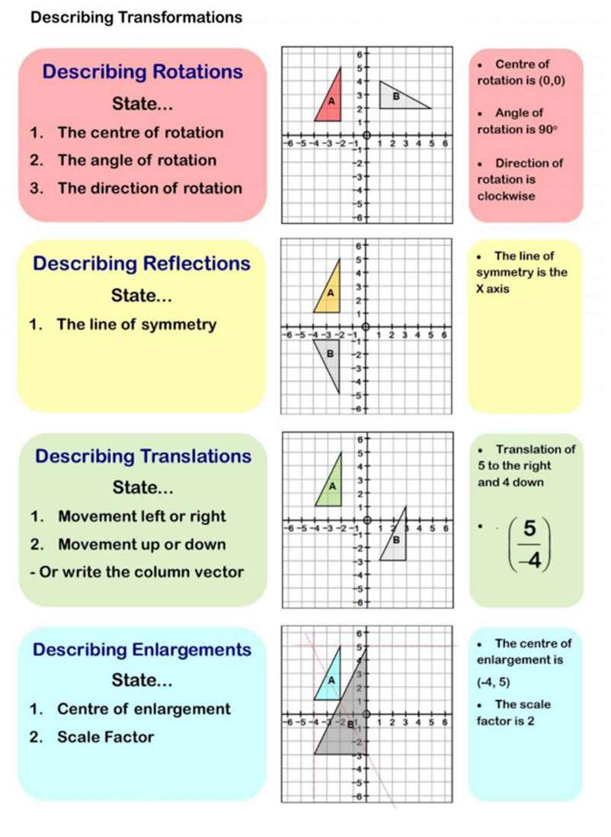
Autumn Term 2 Knowledge


Scan for full list of Maths facts

