Knowledge Organiser
Autumn Term 2 Set 3c Year 10
Topic | Self-Assessment | Independent Learning and  homework tasks
Topic | Self-Assessment | MyMaths | CorbettMaths.com
Solving linear equations (4) |  | Algebra, Equations – Linear, Solving Equations | Video 110
Solving linear equations with fractions (5) |  | Algebra, Equations – Linear, Solving Equations With Fractions | Video 111
Forming linear expressions (4) |  | N/A | Video 115
Convert fractions, decimals & percentages (3/4) |  | Number, Percentages, Frac Dec Perc 2 | FDP  Videos 121 to 131
Converting recurring decimals to fractions (7) |  | Number, Decimals, Fractions, Recurring Decimals 2 | Video 96
Finding percentage of a quantity and one quantity as a percentage of another (3) |  | Number, Percentages, Percentage of Amounts 2 | Video 50 - 52
Percentage increase and decrease (4) |  | Number, Percentages, Percentage Change 1 | Percentage Change video 233
Reverse Percentages (6) |  | Number, Percentages, Percentage Change 2 | Percentages: Reverse video 240
Compound interest (5) |  | Number, Percentages, Percentage Change 2 | Percentages: Compound Interest video 236
Calculating Profit & Loss |  | NA | NA

Stretch and Challenge:
Set up an account on parallel.org.uk website, using your school email address and use teacher code “ha52kh”
Support:
Attend Maths Clinic one lunch time each week

Autumn Term 2 Knowledge
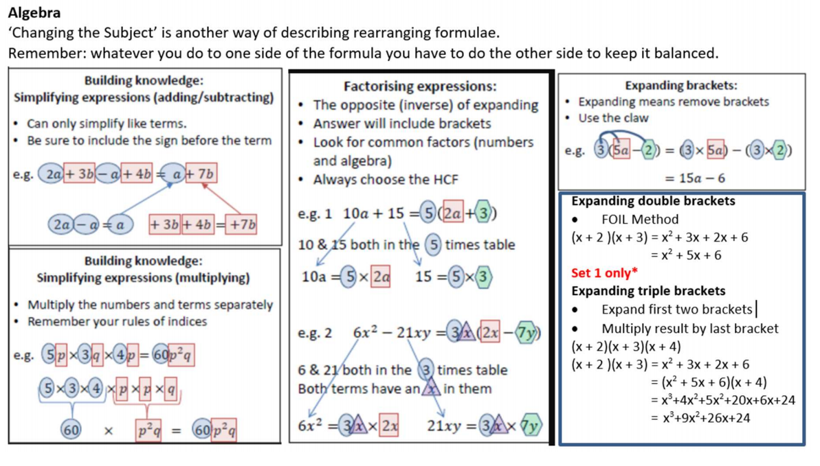


Scan for full list of Maths facts

