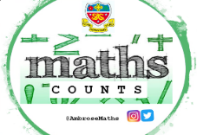
Knowledge Organiser
Autumn Term 2 Set 2 Year 11
Topic | Self-Assessment | Independent Learning and  homework tasks
Topic | Self-Assessment | MyMaths | CorbettMaths.com
Changing the subject where the new subject appears once |  | Algebra, Expression & Formulae, Rearranging 1 | Algebra/Changing the subject  video 8
Changing the subject where the new subject appears more than once |  | Algebra, Expression & Formulae, Rearranging 2 | Algebra/Changing the subject  video 8
Understanding index notation |  | Number, Powers and roots, Indices 1 | Video 174
Multiplying, dividing and raising one power to another power. |  | Number, Powers and roots, Indices 1 | Video 175
Understanding and using negative indices |  | Number, Powers and roots, Indices 2 | Video 173
Being able to evaluate fractional indices |  | Number, Powers and roots, Indices 3 | Video 173
Finding a fraction of a quantity, ordering fractions and simplifying fractions. |  | Number, Fractions, Fractions of amounts / ordering and simplifying fractions | Video 137 / 144
Adding, subtracting & multiplying fractions. |  | Number, Fractions | Video 132 - 137
Understanding reciprocals and dividing fractions |  | Number, Fractions, Dividing Fractions | Video 134
Add, subtract, multiply and divide algebraic fractions |  | Algebra, Algebraic Manipulation | Video 21 - 24
Solve equations involving fractions with algebraic denominators |  | Algebra, Algebraic Manipulation | Video 110 - 112

Stretch and Challenge:
- Practise UKMT Intermediate Maths Challenge Past papers on:
https://www.ukmt.org.uk/competitions/solo/intermediate-mathematical-challenge/archive
- Set up an account on parallel.org.uk website, using your school email address and use teacher code “ha52kh”

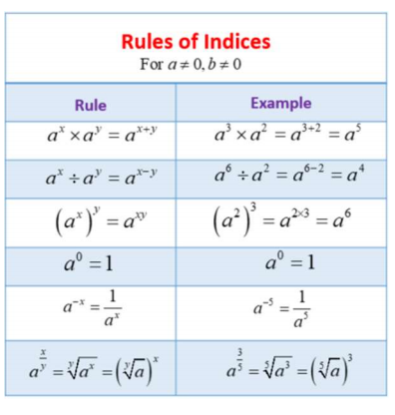
Autumn Term 2 Knowledge

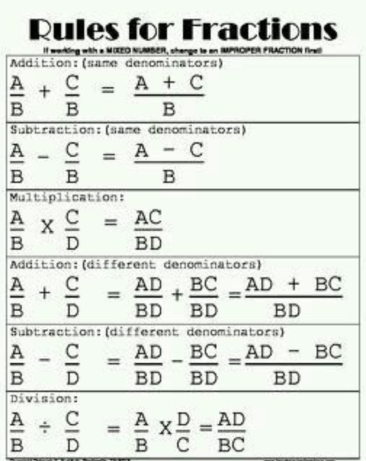


Scan for full list of Maths facts

