Knowledge organiser for KS3 Science Biology Structure & function of body systems at Saint Ambrose College 2020+
What is covered in this unit?
The hierarchical organisation of multicellular organisms: from cells to tissues to organs to systems to organisms. The structure and functions of the gas exchange system in humans, including adaptations to function. The mechanism of breathing to move air in and out of the lungs, using a pressure model to explain the movement of gases, including simple measurements of lung volume.
The impact of exercise, asthma, and smoking on the human gas exchange system. The structure and functions of the human skeleton, to include support, protection, movement, and making blood cells. Biomechanics – the interaction between skeleton and muscles, including the measurement of force exerted by different muscles. The function of muscles and examples of antagonistic muscles.
Key vocabulary Respiratory- inhale, exhale, system, diaphragm. Movement-musculoskeletal, pivot, hinge, cartilage, synovial.
Key facts-
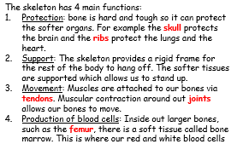
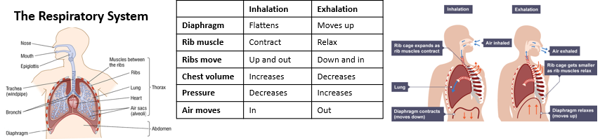
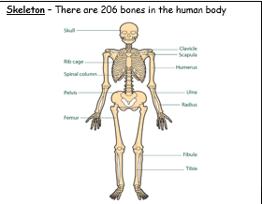
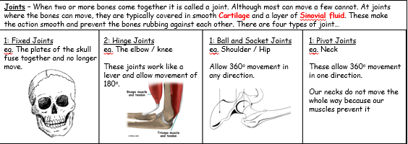
are made.
Possible homework tasks I Stretch & challenge (wider reading/independent work)
H/W:including project, Kerboodle, Kahoot. Stretch: modelling tasks, Biological Science Review research. Oxford Uni H/W

