Knowledge organiser for KS4 Biology Plant Hormones at Saint Ambrose College 2020+
What is covered in this unit?
Hormones to coordinate and control growth; phototropism; geotropism; auxin; gibberellins; ethene; use in agriculture and horticulture
Key vocabulary
Auxin - A type of plant hormone produced at the tips of plant shoots and roots.
Tropism - The response of a plant by growing towards or away from a stimulus
Phototropism - A plants growth response to light
Gravitropism - A plants growth response to gravity
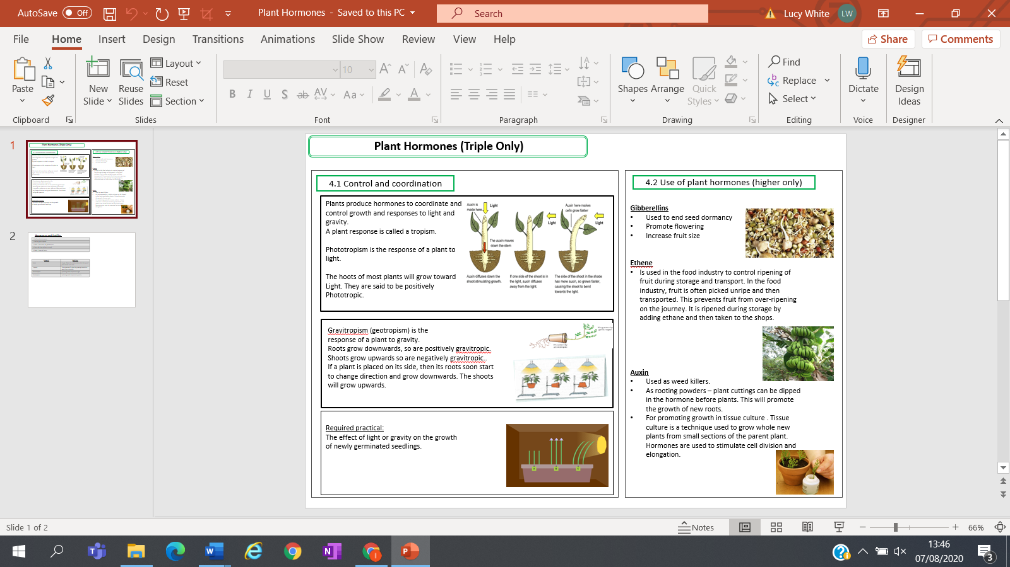
Key facts-
Possible homework tasks I Stretch & challenge (wider reading/independent work)
H/W: including project, Kerboodle, Kahoot, Exam Pro Stretch: modelling tasks, Biological Science Review research, Oxford Uni

