Knowledge organiser for KS4 Biology Photosynthesis at Saint Ambrose College 2020+
What is covered in this unit?
Photosynthesis reaction; endothermic reaction; rate of photosynthesis; solve simple algebraic equations; explain graphs pf photosynthesis rate; inverse proportion; limiting factors; uses of glucose from photosynthesis ; production protein
Key vocabulary
Endothermic - A reaction that requires energy to be absorbed to work.
Limiting factor - Anything that reduces or stops the rate of a reaction.
Chlorophyll - Chemical pigment found in the chloroplast
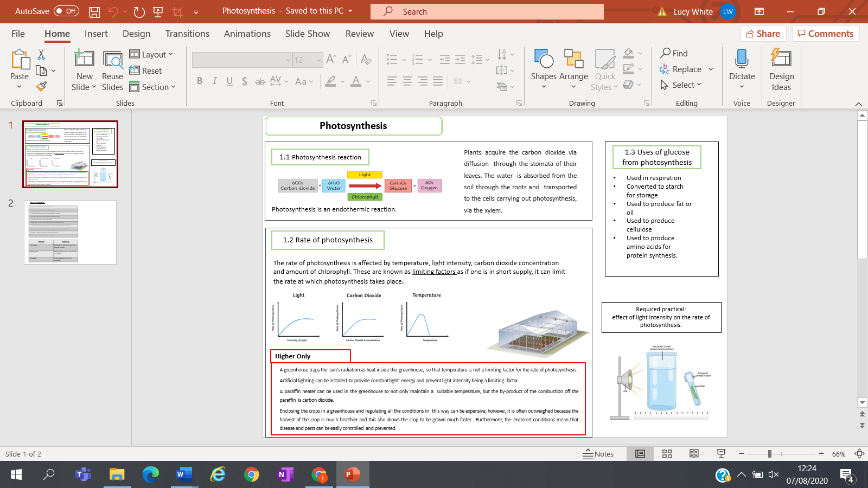
Key facts-

Possible homework tasks I Stretch & challenge (wider reading/independent work)
H/W: including project, Kerboodle, Kahoot, Exam Pro Stretch: modelling tasks, Biological Science Review research, Oxford Uni

