Knowledge organiser for KS4 Biology Plants and Transpiration at Saint Ambrose College 2020+
What is covered in this unit?
Structure of plant tissues relate to their functions; structure of root hair cells, xylem and phloem; rate of transpiration; plant organ system; process of transpiration and translocation; xylem tissue; role of stomata and guard cells; phloem tissue
Key vocabulary
Guard Cells - surround the stomata in the leaves of plants and control their opening and closing
Transpiration - the loss of water vapour from the leaves of plants through the stomata when they are opened to allow gas exchange for photosynthesis. It involves evaporation from the surface of the cells and diffusion through the stomata
Phloem - the living transport tissue in plants that carries dissolved food (sugars) around the plant
Translocation - the movement of sugars from the leaves to the rest of the plant through the phloem
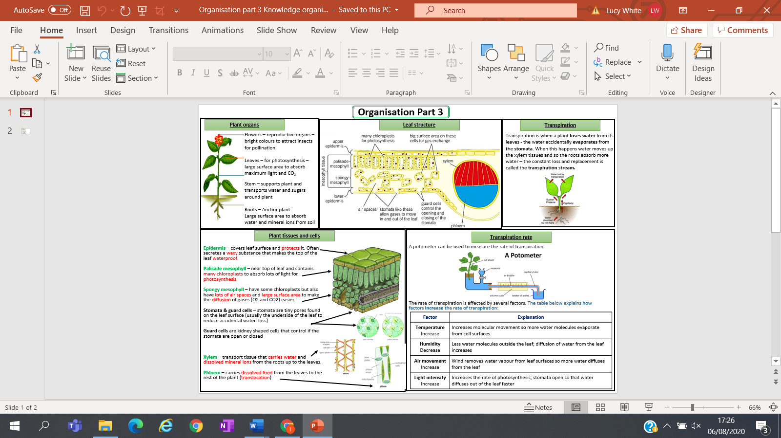
Key facts-

Possible homework tasks I Stretch & challenge (wider reading/independent work)
H/W: including project, Kerboodle, Kahoot, Exam Pro Stretch: modelling tasks, Biological Science Review research, Oxford Uni

