Knowledge organiser for KS4 Biology Genetics and Speciation at Saint Ambrose College 2020+
What is covered in this unit?
Work of Mendel; behaviour of chromosomes; structure of DNA; gene theory; Darwin and Wallace
Key vocabulary
Gene - Section of DNA which codes for a particular amino acid.
Chromosome - Made of the chemical DNA. Found in the nucleus.
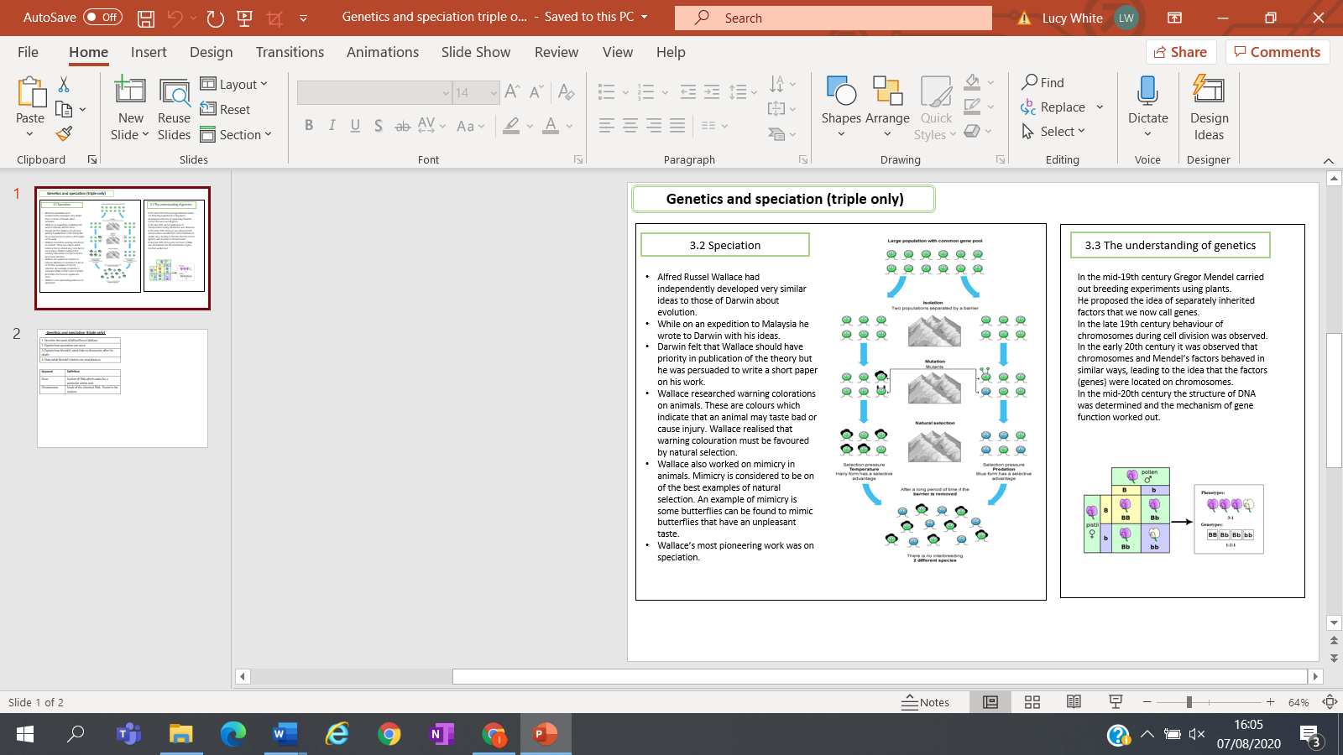
Key facts-

Possible homework tasks I Stretch & challenge (wider reading/independent work)
H/W:including project, Kerboodle, Kahoot, Exam Pro Stretch: modelling tasks, Biological Science Review research, Oxford Uni

