Knowledge organiser for KS4 Biology Selective Breeding and Genetic Engineering at Saint Ambrose College 2020+
What is covered in this unit?
Impact selective breeding food plants and domesticated animals; artificial selection; desired characteristics, usefulness or appearance; inbreeding; genetic engineering; plant crops resistant bacteria; insulin from bacteria; benefits and risks engineering agriculture and medicine; genes ‘cut out’; genetically modified crops; effect on populations wild flowers and insects; inherited disorders; main steps process genetic engineering
Key vocabulary
Selective Breeding - Also known as artificial selection. A technique of improving domesticated animals and plants for humans benefit, by breeding for particular genetic characteristics.
Genetic engineering - The process by which scientists manipulate and change the genotype of an organism
Genetically modified - GM for short. Describes organisms (especially crops) that have had their genome modified by genetic engineering
Vector - In the context of genetic engineering, a vector is a piece of genetic material used to transfer a gene. It is usually a bacterial plasmid or virus.
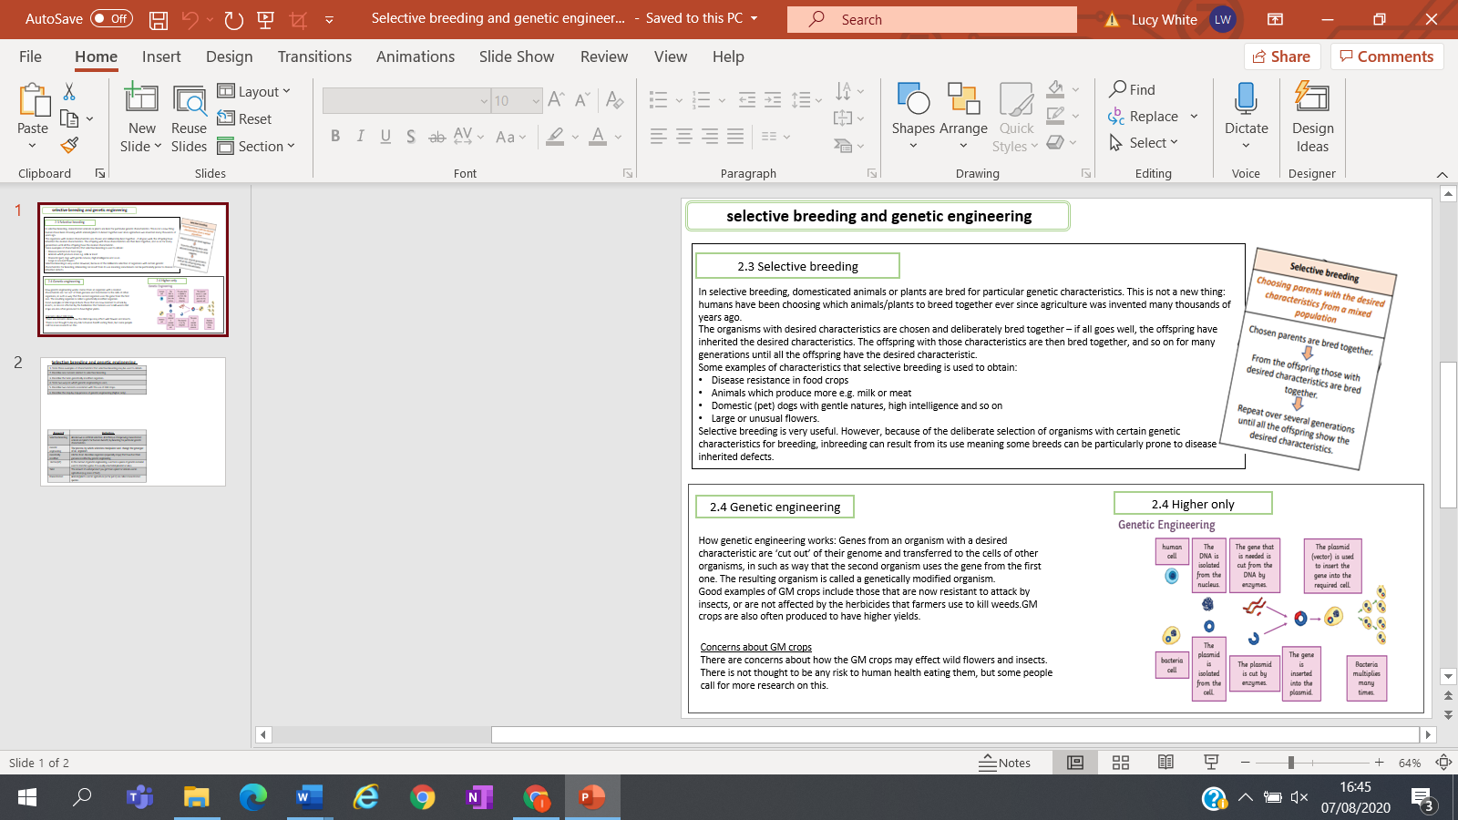
Key facts-

Possible homework tasks I Stretch & challenge (wider reading/independent work)
H/W: including project, Kerboodle, Kahoot, Exam Pro Stretch: modelling tasks, Biological Science Review research, Oxford Uni

