Knowledge organiser for KS4 Biology Communicable Diseases at Saint Ambrose College 2020+
What is covered in this unit?
Infectious diseases; spread of disease; viral diseases; bacterial diseases; fungal diseases; protist diseases; human defence systems; vaccination; antibiotics and painkillers; discovery and development of drugs
Key vocabulary
Infectious – Describes a pathogen that can be easily transmitted, or an infected person who can pass on the disease
Vector - An animal that spreads a communicable disease
Malaria - A communicable disease, caused by a protist transmitted in mosquitos, which attacks red blood cells
Protist - A type of single-celled pathogen that causes malaria
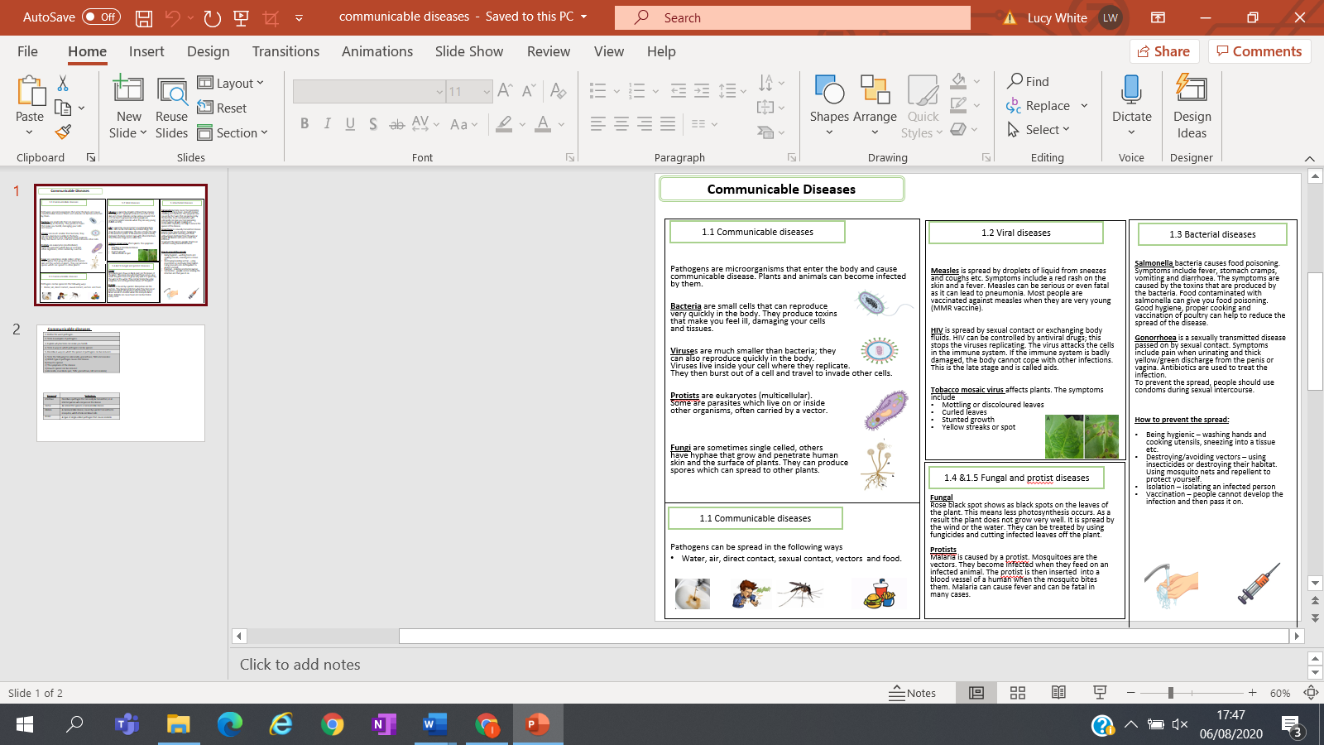
Key facts-

Possible homework tasks I Stretch & challenge (wider reading/independent work)
H/W: including project, Kerboodle, Kahoot, Exam Pro Stretch: modelling tasks, Biological Science Review research, Oxford Uni

