Knowledge organiser for KS4 Biology Culturing Microorganisms at Saint Ambrose College 2020+
What is covered in this unit?
Simple cell division; nutrient broth solutions or colonies; uncontaminated cultures; aseptic technique ; cross-sectional areas; mean division time; standard form
Key vocabulary
Control - Allows us to compare our results. E.g. the filter paper with no antibiotic or antiseptic is the control. No bacteria should be destroyed surrounding the filter paper. If it is then there is contamination in the practical.
Zone of Inhibition – Area where bacteria have been destroyed/killed
Incubated – Grown in a warm, constant environment
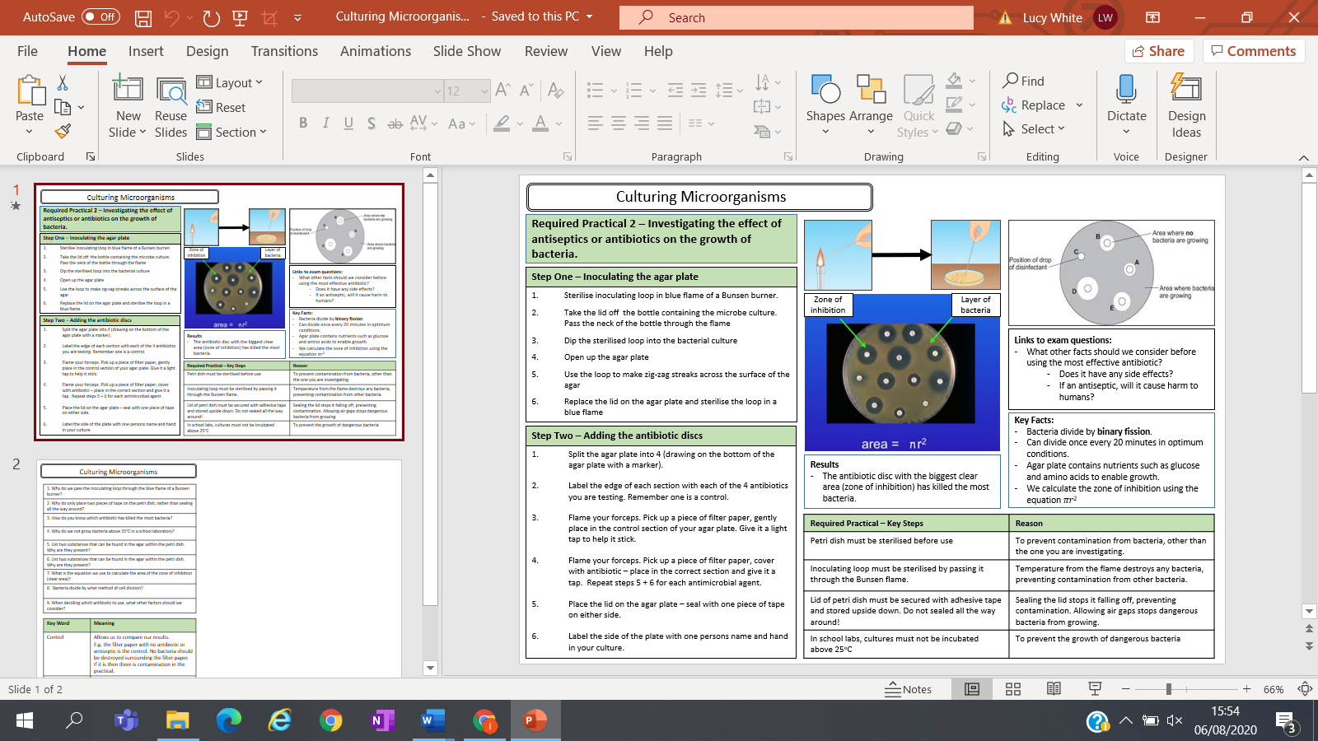
Key facts-

Possible homework tasks I Stretch & challenge (wider reading/independent work)
H/W: including project, Kerboodle, Kahoot, Exam Pro Stretch: modelling tasks, Biological Science Review research, Oxford Uni

