Knowledge organiser for KS4 Biology Fighting Infection at Saint Ambrose College 2020+
What is covered in this unit?
Non-specific defence systems against pathogens; role of the immune system; white blood cells
Key vocabulary
Antibiotic - A group of medicines, first discovered by Alexander Fleming, that kill bacteria and fungi but not viruses.
Antitoxin - A protein produced by your body to neutralize harmful toxins produced by pathogens
Double blind trial - A medical experiment in which the patient and doctors do not know who has been given the drug and who has been given the placebo
Antibodies - Highly specific Y-shaped proteins that are produced by the immune system to help stop intruders from harming the body
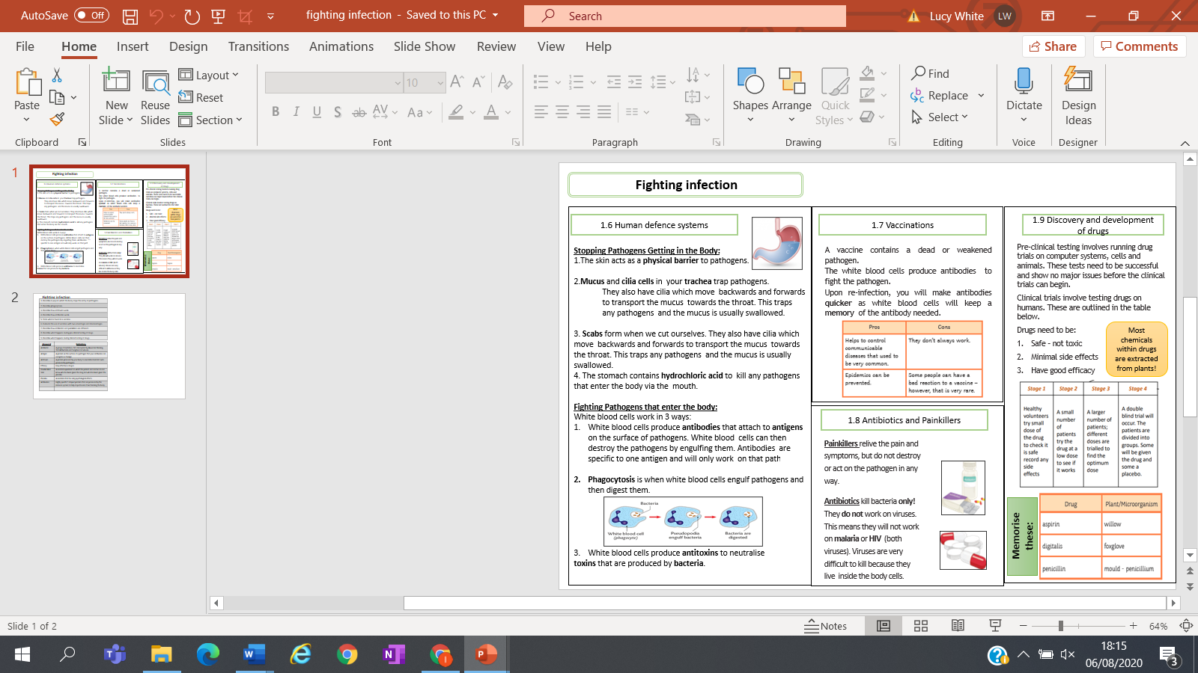
Key facts-

Possible homework tasks I Stretch & challenge (wider reading/independent work)
H/W: including project, Kerboodle, Kahoot, Exam Pro Stretch: modelling tasks, Biological Science Review research, Oxford Uni

