Knowledge organiser for KS4 Biology Homeostasis and the nervous system at Saint Ambrose College 2020+
What is covered in this unit?
Homeostasis definition; automatic control systems; structure of nervous systems and its adaptations; central nervous systems; reflex arc
Key vocabulary
Homeostasis - Regulation of internal conditions to maintain optimal conditions for enzyme action and cell function
Central Nervous System - The brain and spinal cord. Sometimes referred to as the coordinator
Reflex response - An automatic response that you do not think about
Stimulus - A change in the environment such as noise, smell or temperature change
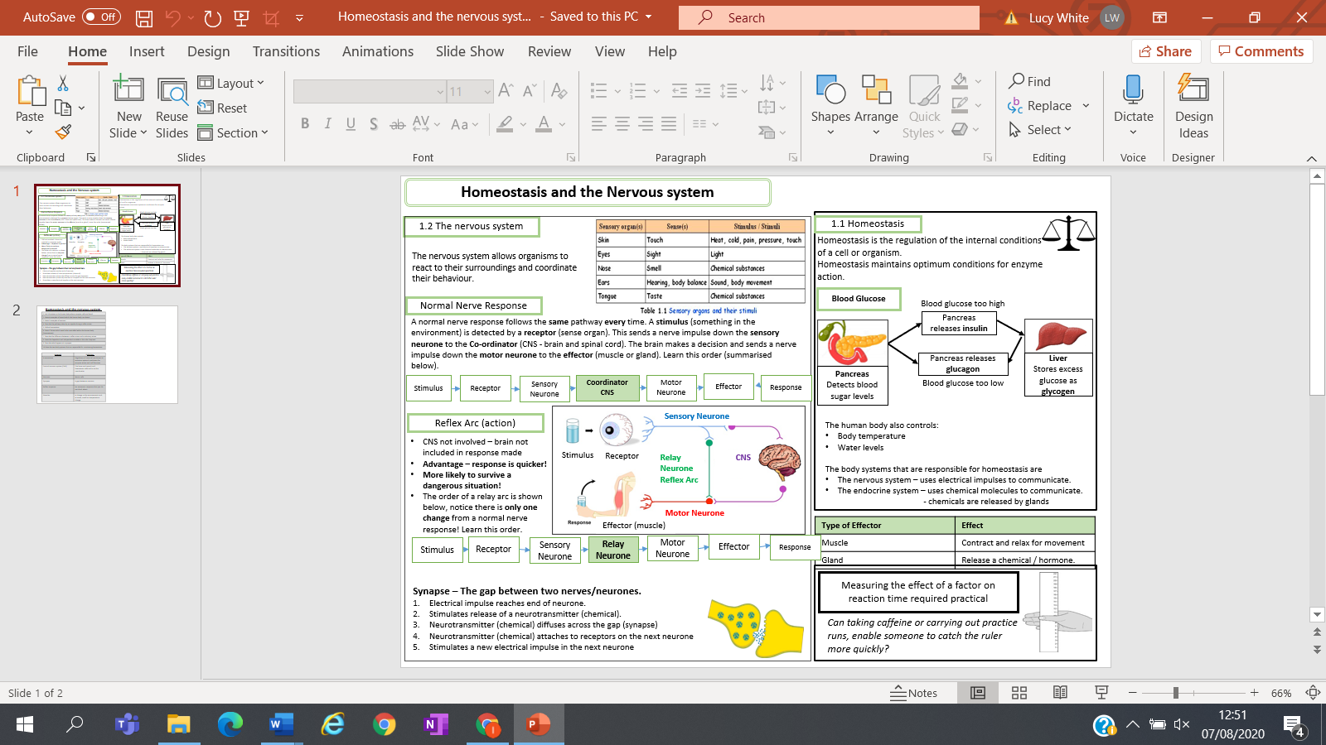
Key facts-

Possible homework tasks I Stretch & challenge (wider reading/independent work)
H/W: including project, Kerboodle, Kahoot, Exam Pro Stretch: modelling tasks, Biological Science Review research, Oxford Uni

