Knowledge organiser for KS4 Biology Monoclonal antibodies and plant diseases at Saint Ambrose College 2020+
What is covered in this unit?
Production monoclonal antibodies; specificity antibodies; stimulation lymphocytes and hybridoma cells; uses of monoclonal antibodies; advantages and disadvantages of monoclonal antibodies; detection and identification of plant diseases; infection plants by pathogens and insects; physical and chemical plant defence responses
Key vocabulary
Monoclonal antibody - Antibodies made from cells that are cloned from one cell that are specific to one binding site on an antigen. They are used in medicine to treat cancer and in research.
Hybridoma cell - Cells made from combining tumour cells with lymphocytes, to make cells that can produce antibodies and divide (for the production of monoclonal antibodies)
Lymphocyte – A form of white blood cell
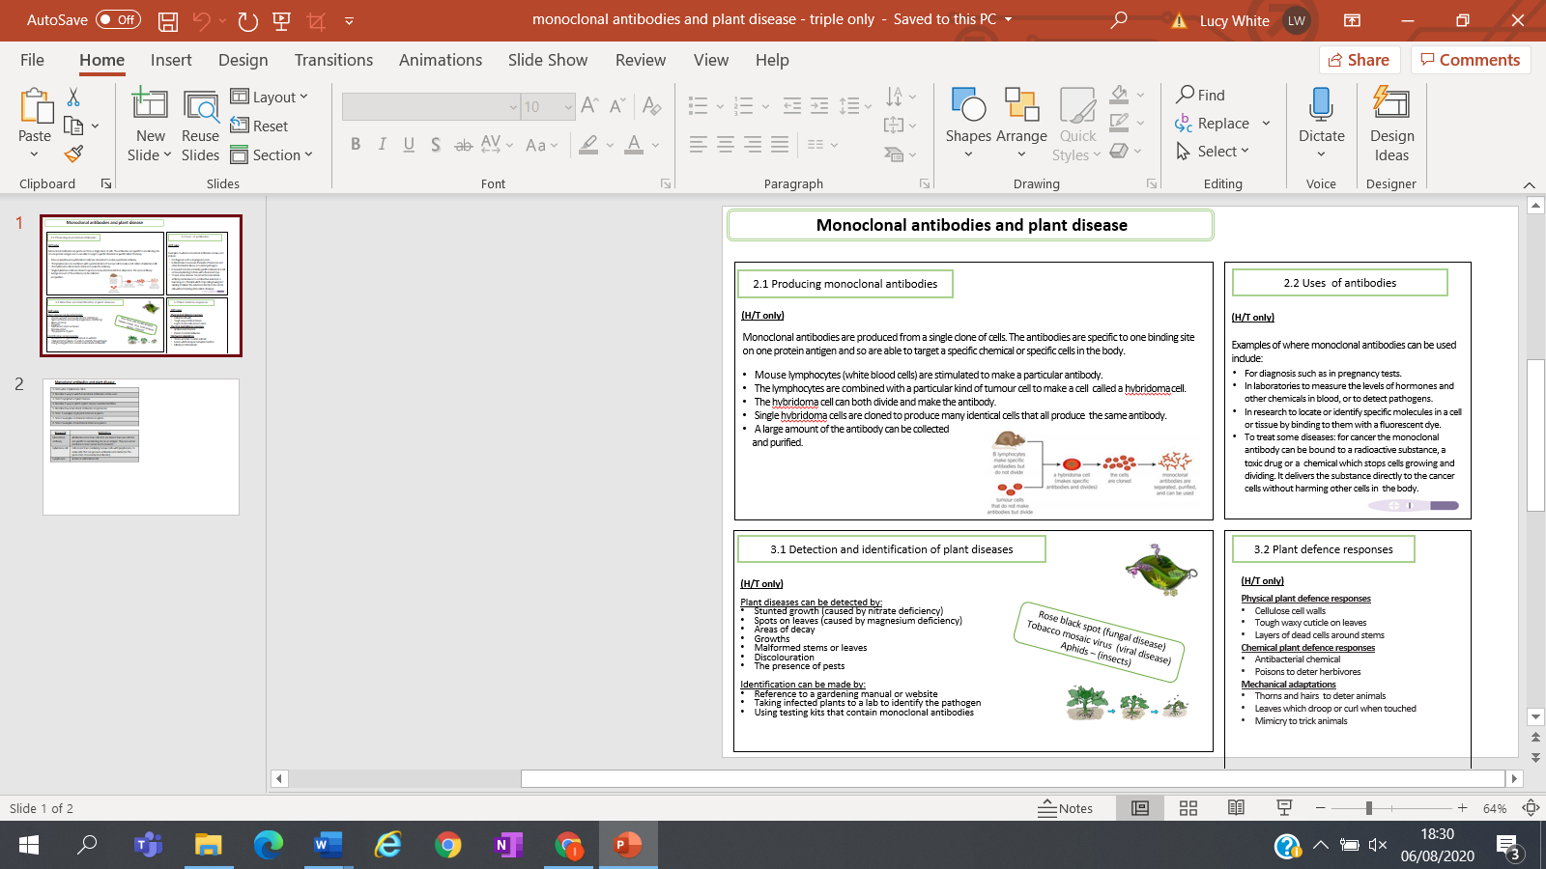
Key facts-
Possible homework tasks I Stretch & challenge (wider reading/independent work)
H/W: including project, Kerboodle, Kahoot, Exam Pro Stretch: modelling tasks, Biological Science Review research, Oxford Uni

