Knowledge organiser for KS4 Biology Evidence for evolution at Saint Ambrose College 2020+
What is covered in this unit?
Evidence for evolution, fossils and antibiotic resistance in bacteria; theory of evolution by natural selection; Darwin’s theory
Key vocabulary
Fossil - The remains of organisms from millions of years ago, found in rocks
Strain - A variant of microorganism within a species – so they are not a different species to other variants, but have a key difference in their phenotype (e.g. being resistant to an antibiotic). New strains are produced by mutations
MRSA - Describes a variant form of bacteria with resistance (NOT immunity) to a specific antibiotic
Extinction - When No individuals of a species remain alive
Key facts-
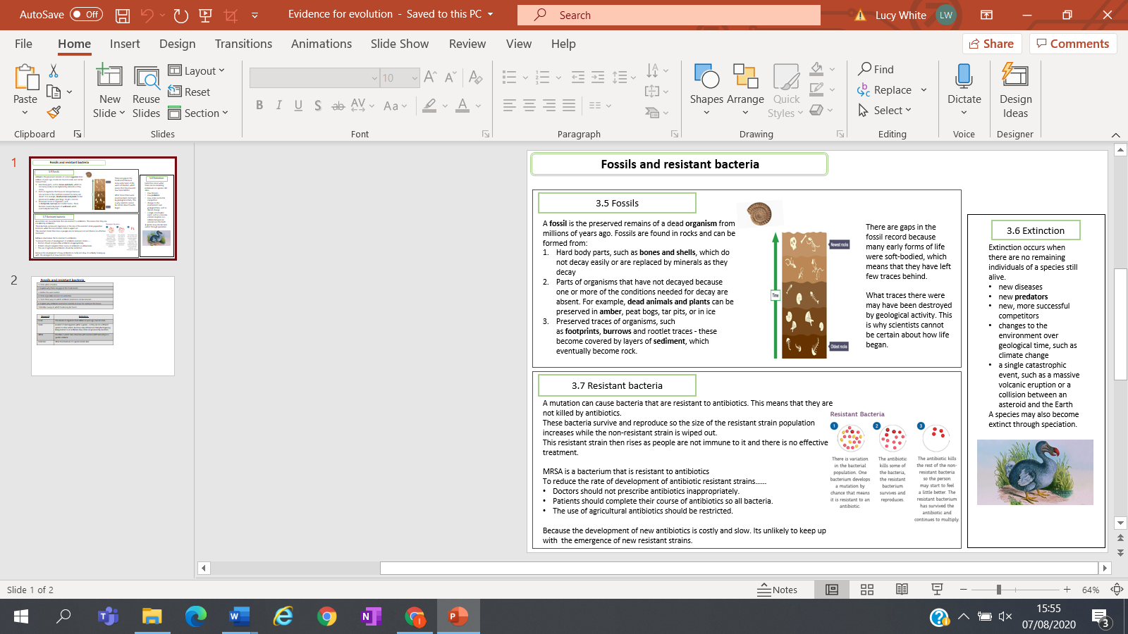

Possible homework tasks I Stretch & challenge (wider reading/independent work)
H/W: including project, Kerboodle, Kahoot, Exam Pro Stretch: modelling tasks, Biological Science Review research, Oxford Uni

