Knowledge organiser for KS4 Biology Human Impact on the environment at Saint Ambrose College 2020+
What is covered in this unit?
Increase in waste production; higher levels of pollution; reduction of biodiversity; reduction of land available; destruction of peat areas; decay/destruction of peat; deforestation; global warming; levels of carbon dioxide and methane; negative and positive interactions with the ecosystem
Key vocabulary
Biomass - The materials that living things are made from: proteins, carbohydrates, and lipids.
Food chain - Used to represent the feeding relationships in a community. Starts with a producer and shows what organism eats what, as well as how energy and biomass are transferred in the community.
Trophic level - Position in a food chain. Producers = level 1.
Ingest – Eat/Consume
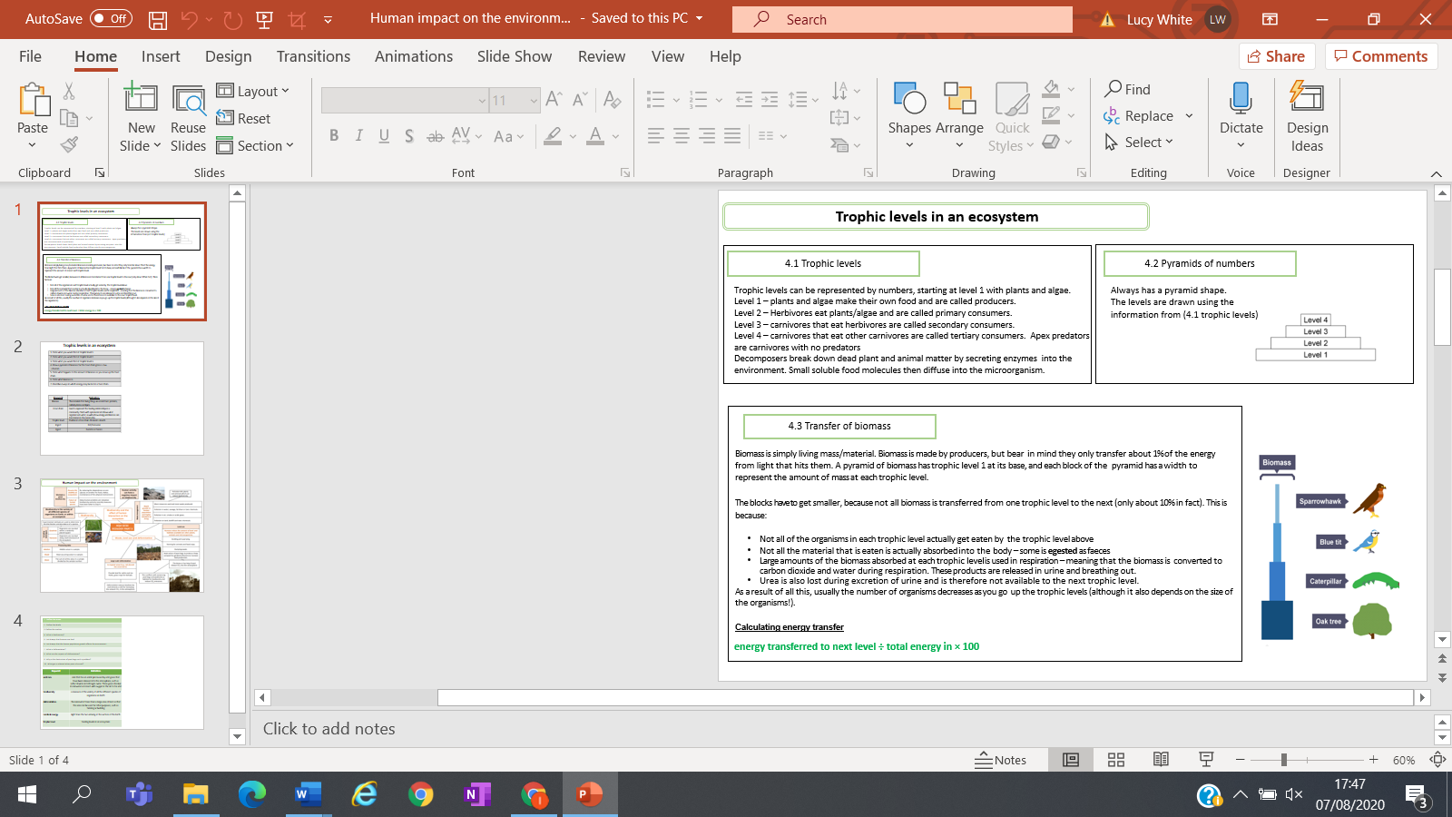
Key facts-

Possible homework tasks I Stretch & challenge (wider reading/independent work)
H/W: including project, Kerboodle, Kahoot, Exam Pro Stretch: modelling tasks, Biological Science Review research, Oxford Uni

