Knowledge organiser for KS4 Biology Variation and Evolution at Saint Ambrose College 2020+
What is covered in this unit?
Development of phenotypes; factors affecting variation; variation within a species; variants arise from mutations; mutations; description evolution; theory evolution by natural selection; fertile offspring
Key vocabulary
Variation - Differences in the characteristics of individuals in a population.
Genetic variation - Differences in the genome between individuals. This often causes differences in physical characteristics.
Mutation - A change to DNA.
Natural selection - The process that changes the inherited characteristics of organisms over time. This explains the adaptations of organisms to their environment AND the formation of new species of organism.
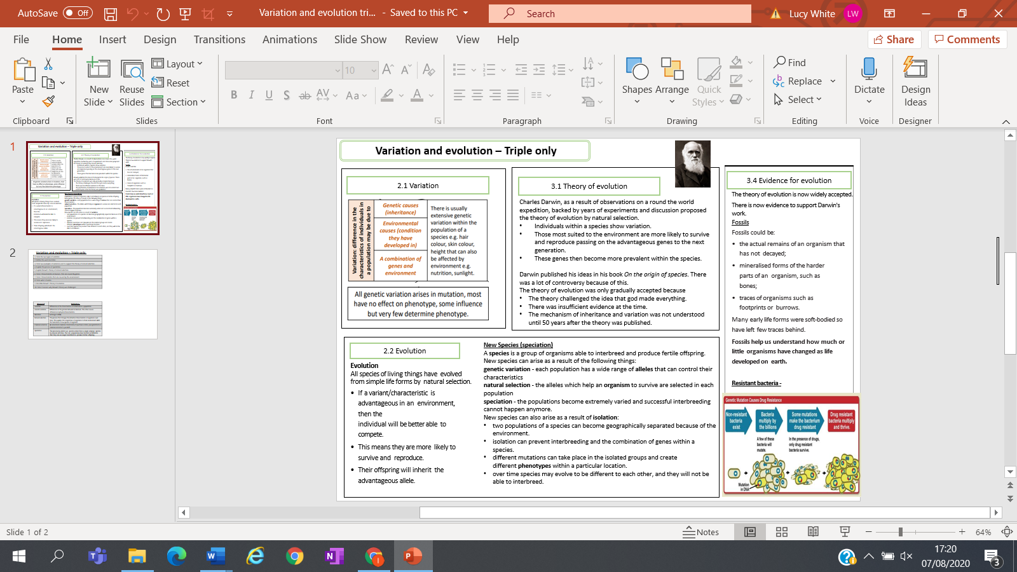
Key facts-

Possible homework tasks I Stretch & challenge (wider reading/independent work)
H/W: including project, Kerboodle, Kahoot, Exam Pro Stretch: modelling tasks, Biological Science Review research, Oxford Uni

