Topic |  |  |  | Independent Learning and homework tasks
Topic |  |  |  | MyMaths | CorbettMaths.com
Understanding data handling cycle, and different data types |  |  |  | Data, Collecting Data | Video 89
Understanding sampling methods including stratified random sampling |  |  |  | Data, Collecting Data, Sampling | Video 281
Calculating probabilities |  |  |  | Data, Probability, Listing Outcomes | Video 245
Estimating relative frequencies |  |  |  | Data, Probability, Relative Frequency | Video 248
Understanding and using two-way tables and frequency trees |  |  |  | Data, Probability, Frequency Trees | Video 246
Understanding mutually exclusive, independent and dependent events |  |  |  | Data, Probability, OR Rule, Independent / Dependent prob… | Video 244
Representing probabilities using tree diagrams |  |  |  | Data, Probability, Conditional Probability 1 & 2 | Video 246
Representing probabilities using Venn diagrams |  |  |  | Data, Probability, Venn diagrams 1 & 2 | Video 380
Knowledge Organiser
Lent Term 2 Set 1 Year 9

Maths Support Attend KS3 Maths Clinic every Friday lunch time for extra help and support.
Stretch and Challenge:
1) Practise UKMT Intermediate Maths Challenge Past papers on ukmt.org.uk
2) Set up an account on parallel.org.uk website, using your school email address and use teacher code “ha52kh”
3) Attend Puzzle Club one lunch time each week


Scan for full list of Year 9 Maths facts

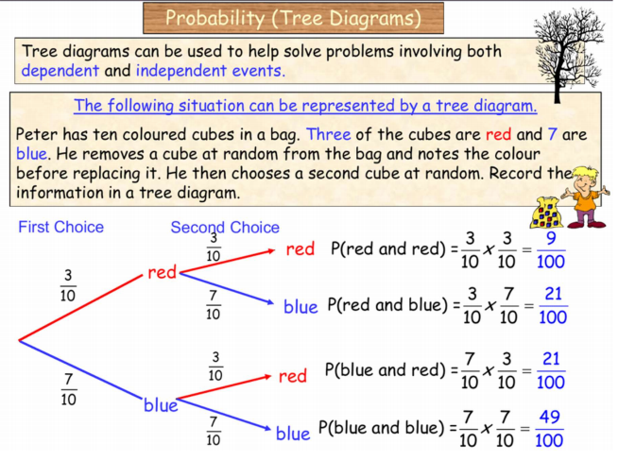
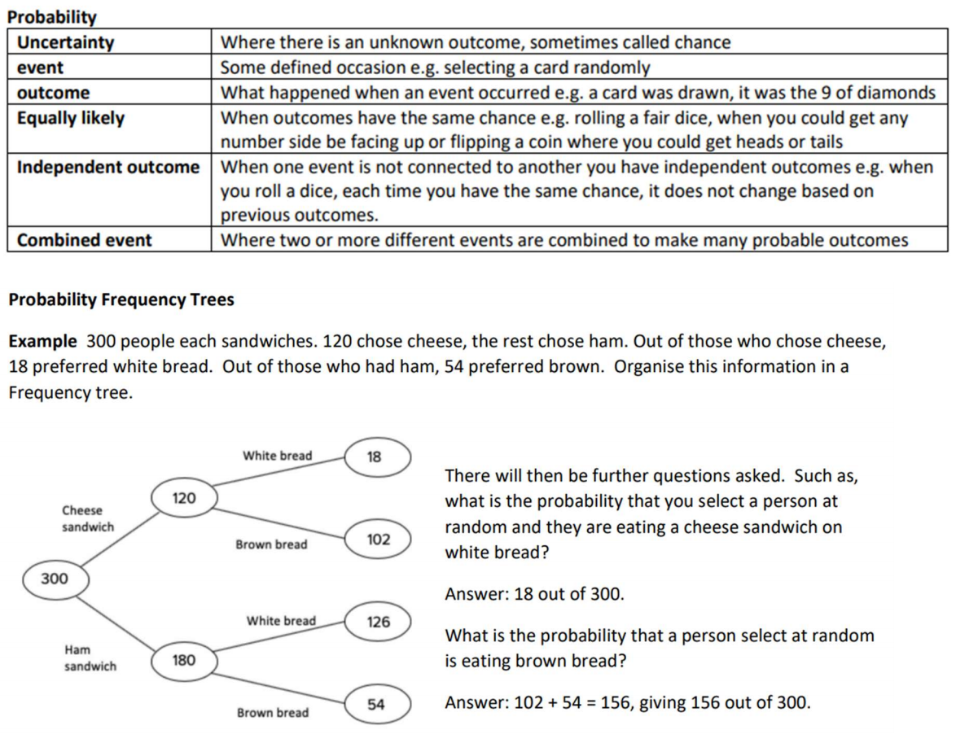
Lent Term 2 Knowledge


