Topic |  |  |  | Independent Learning and homework tasks
Topic |  |  |  | MyMaths | CorbettMaths.com
Use Pythagoras Theorem to find the lengths of unknown sides in right-angled triangles. |  |  |  | Shape, Pythagoras, Pythagoras’ Theorem | Video 257
Find the mid-point and length of a line segment using Pythagoras’ theorem. |  |  |  | Shape, Pythagoras, Pythagoras’ Theorem | Video 258
Understand properties of similar triangles, quadrilaterals and polygons and calculating missing lengths |  |  |  | Shape, Scale and Similarity | Videos 291 - 2
Constructing and interpreting distance, time graphs for constant velocity. |  |  |  | Algebra, Graphs, Distance Time Graphs | Video 171
Constructing and interpreting other real life graphs |  |  |  | Algebra, Graphs, Real Life Graphs | Conversion Graphs Video 151-152
Solving problems involving rate of change
Factorising quadratic expressions |  |  |  | Algebra, Algebra Manipulation, Factorising Quadratics | Factorisations  Video 117 & 118
Solving Quadratic Equations |  |  |  | Algebra, Equations – Quadratics, Quadratic Equations 1 | Solving Quadratics (Factorising)  Video 266
Recognise and use rules for number and pattern sequences |  |  |  | Algebra, Sequences, Recognising Sequences/ Geometric Sequences1 | Video 286 – 7, 287a, 375
Finding the nth term formula of arithmetic sequences |  |  |  | Algebra, Sequences, Arithmetic | Video 374
Understanding index notation |  |  |  | Number, Powers and roots, Indices 1 | Video 174
Understanding and using negative indices |  |  |  | Number, Powers and roots, Indices 2 | Video 175
Knowledge Organiser
Lent Half Term2 Set 3 Year 9

Lent Term 2 Knowledge

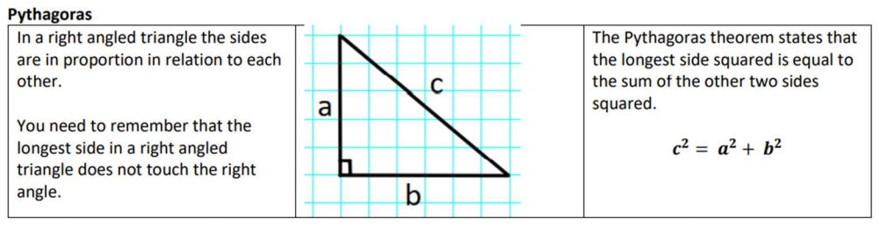

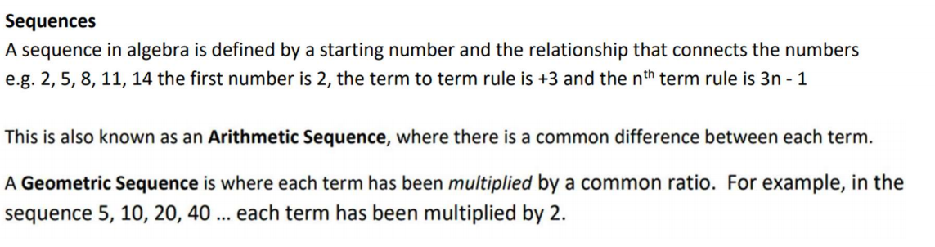

Maths Support
Attend KS3 Maths Clinic every Friday lunch time for extra help and support.
Stretch and Challenge:
Set up an account on parallel.org.uk website, using your school email address and use teacher code “ha52kh”


Scan for full list of Maths Knowledge

