Knowledge organiser for KS5 Biology Cell structure at Saint Ambrose College 2020+
What is covered in this unit?
Optical microscopes; magnification; structure and function of eukaryotic cells and their contents; specialised cells; prokaryotic cells; structure of viruses; mitosis; behaviour of chromosomes; role of spindle fibres; cytokinesis; binary fission; the cell cycle
Key vocabulary
Resolution – the minimum distance apart two objects can be in order for them to appear as separate items
Cell fractionation – the process where cells are broken up and the different organelles they contain are separated out
Mitosis – produces two daughter cells that have the same number of chromosomes as the parent cell and each other
Meiosis – produces four daughter cells each with half the number of chromosomes of the parent cell
Cell cycle – regular cycle of division separated by periods of cell growth
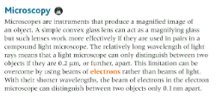
Key facts-
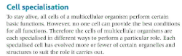
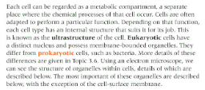

Possible homework tasks I Stretch & challenge (wider reading/independent work)
H/W:including project, Kerboodle, Kahoot, Exam Pro Stretch: modelling tasks, Biological Science Review research, Oxford Uni

