Knowledge organiser for KS5 Biology Defence Mechanisms at Saint Ambrose College 2020+
What is covered in this unit?
Molecule identifiers on cells; phagocytosis; T-lymphocytes; role of antigen-presenting cells; role of helper T cells; responses of B lymphocytes; antibodies; formation of antigen-antibody complex; roles of plasma and memory cells; use of monoclonal antibodies; use of vaccines; concept of herd immunity; differences between active and passive immunity; structure of HIV; use antibiotics against viruses; ethical issues with vaccines; use of antibodies
Key vocabulary
Antigen – any part of an organism or substance that is recognised as non-self by the immune system and stimulates an immune response
Immunity – the ability of an organism to resist infection
Vaccination – the introduction of the appropriate disease antigens into the body, either by mouth or injection
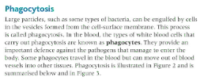
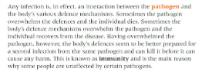
Key facts-
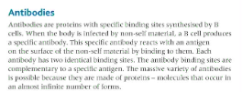

Possible homework tasks I Stretch & challenge (wider reading/independent work)
H/W: including project, Kerboodle, Kahoot, Exam Pro Stretch: modelling tasks, Biological Science Review research, Oxford Uni

