Knowledge organiser for KS5 Biology DNA, Genes, and protein synthesis at Saint Ambrose College 2020+
What is covered in this unit?
Genes and the triplet code; DNA and chromosomes, histones; the structure of ribonucleic acid; protein synthesis – transcription and splicing, role of RNA polymerase; protein synthesis – translation, roles of ribosomes, transfer RNA and ATP
Key vocabulary
Gene – section of DNA that contains the coded information for making polypeptides and functional RNA
Homologous pair – always two chromosomes that carry the same genes but not necessarily the same alleles of the genes
Genome – the complete set of genes in a cell, including those in mitochondria and/or chloroplasts
Proteome – the full range of proteins produced by the genome
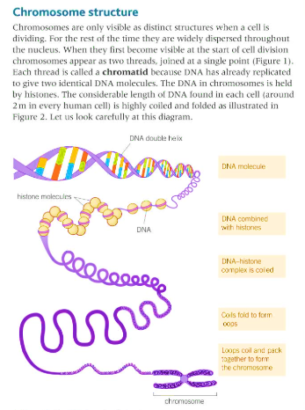
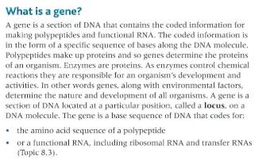
Key facts-
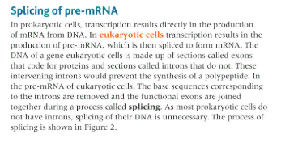

Possible homework tasks I Stretch & challenge (wider reading/independent work)
H/W: including project, Kerboodle, Kahoot, Exam Pro Stretch: modelling tasks, Biological Science Review research, Oxford Uni

