Knowledge organiser for KS5 Biology Energy and Ecosystems at Saint Ambrose College 2020+
What is covered in this unit?
Synthesis of organic compounds; function of sugars synthesised; Biomass; Chemical energy store; Gross primary production; Net primary production; Simplification food webs to reduce energy losses; Reduce respiratory losses within human food chains
Key vocabulary
Biomass – the total mass of living organisms in a specific area at a given time
Producers – photosynthetic organisms that manufacture organic substances using light energy, water, carbon dioxide and mineral ions
Saprobionts – are a group of organisms that break down the complex materials in dead organisms into simple ones
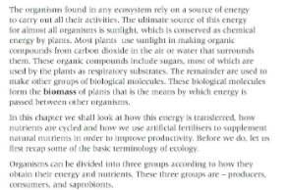
Key facts-
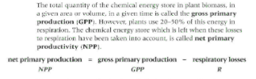
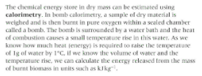

Possible homework tasks I Stretch & challenge (wider reading/independent work)
H/W:including project, Kerboodle, Kahoot. Stretch: modelling tasks, Biological Science Review research.

