Knowledge organiser for KS5 Biology Evolution may lead to speciation at Saint Ambrose College 2020+
What is covered in this unit?
Variation in phenotype within population species; Genetic and environmental factors; Mutation and Meiosis; Natural selection; Phenotypes selective advantages; Effects of stabilising, directional and disruptive selection; Evolution; Reproductive separation; Allopatric and sympatric speciation, importance genetic drift
Key vocabulary
Gene pool – total number of all the alleles of all the genes of all the individuals within a population at any given time
Speciation – the evolution of a new species from existing ones
Adaptive radiation – different phenotypes each combination of alleles produces will be subject to selection pressure which will lead to each population becoming adapted to its local environment
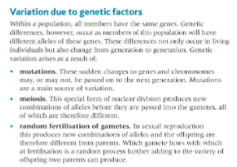
Key facts-
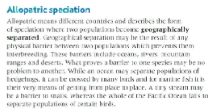
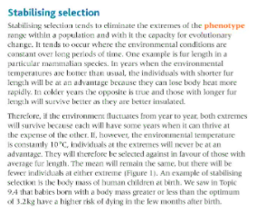

Possible homework tasks I Stretch & challenge (wider reading/independent work)
H/W:including project, Kerboodle, Kahoot. Stretch: modelling tasks, Biological Science Review research.

