Knowledge organiser for KS5 Biology Exchange at Saint Ambrose College 2020+
What is covered in this unit?
Surface area to volume ratio; adaptations that facilitate exchange; adaptations of gas exchange surfaces, single-celled organisms, tracheal system, gills of a fish, leaves; limitation of water loss; structure of the human gas exchange; mechanism of breathing; the alveolar epithelium; ventilation; digestion; mechanisms for the absorption of the products of digestion
Key vocabulary

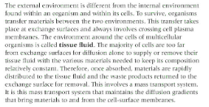
Key facts-
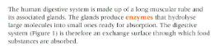
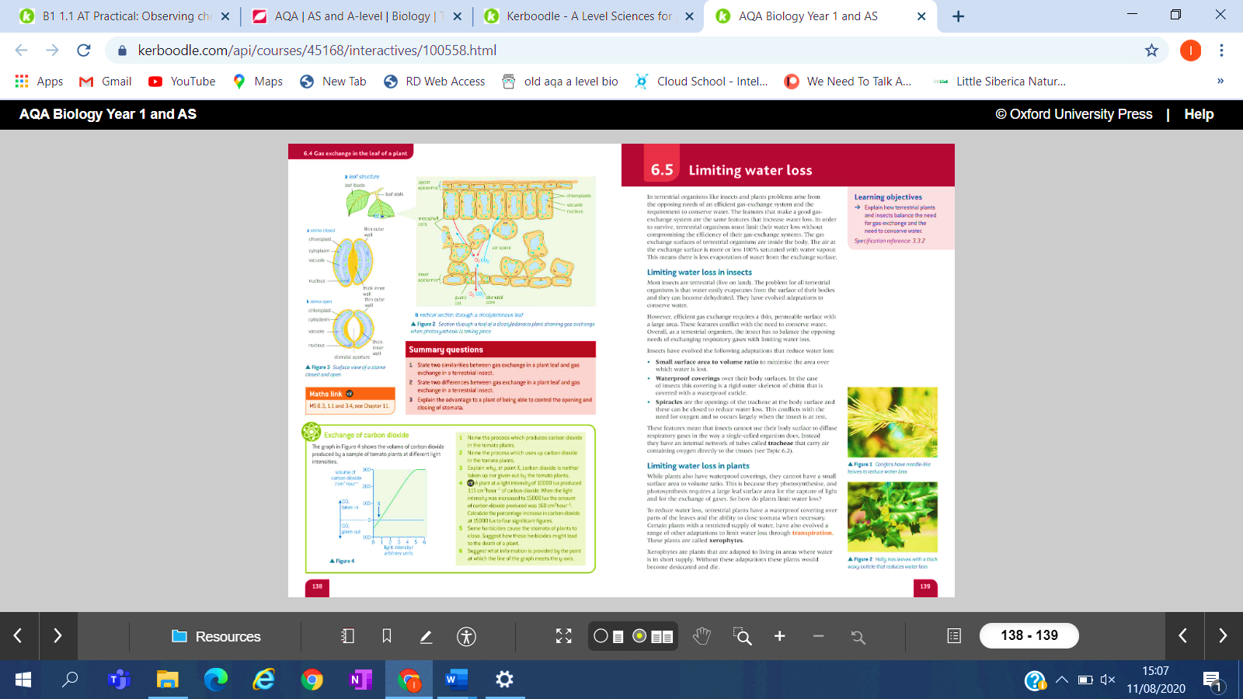

Possible homework tasks I Stretch & challenge (wider reading/independent work)
H/W: including project, Kerboodle, Kahoot, Exam Pro Stretch: modelling tasks, Biological Science Review research, Oxford Uni

