Knowledge organiser for KS5 Biology Gene expression is controlled by a number of features at Saint Ambrose College 2020+
What is covered in this unit?
Totipotent cells; Cell specialisation; Pluripotent, unipotent and multipotent cells; Use of stem cells intreating human disorders; Transcription; Role of oestrogen; Epigenetics; Increased methylation; Decreased acetylation, Translation mRNA; Characteristics benign and malignant tumours; Tumour suppressor genes and oncogenes, abnormal methylation, increased oestrogen concentrations
Key vocabulary
Cell differentiation – the process by which each cell develops into a specialised structure suited to the role it will carry out
Totipotent cells – cells that can mature into any body cell
Stem cells – cells that once they matured and specialised can no longer develop into other cells
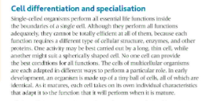
Key facts-
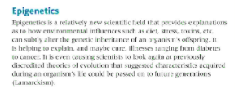
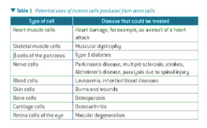

Possible homework tasks I Stretch & challenge (wider reading/independent work)
H/W:including project, Kerboodle, Kahoot. Stretch: modelling tasks, Biological Science Review research.

