Knowledge organiser for KS5 Biology Gene technologies allow the study and alteration of gene function allowing a better understanding of organism function and the design of new industrial and medical processes at Saint Ambrose College 2020+
What is covered in this unit?
Recombinant DNA technology; Production fragments DNA; In vitro and in vivo techniques; Polymerase chain reaction; Transformed host cells; Use labelled DNA probes and DNA hybridisation; Genetic counselling and personalised medicine; Variable number tandem repeats; Technique genetic fingerprinting; Use of genetic fingerprinting
Key vocabulary
Recombinant DNA technology – the processes by which genes are manipulated, altered or transferred from an organism to organism
In vitro – refers to experiments carried out outside the living body
In vivo – refers to experiments that are carried out within living bodies
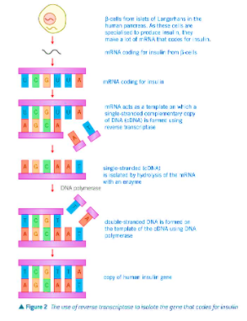
Key facts-
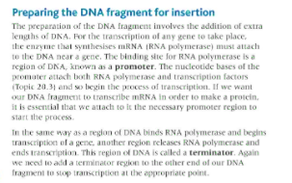
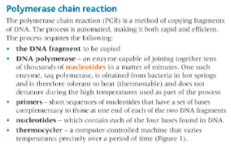

Possible homework tasks I Stretch & challenge (wider reading/independent work)
H/W:including project, Kerboodle, Kahoot. Stretch: modelling tasks, Biological Science Review research.

