Knowledge organiser for KS5 Biology Genetic Diversity and adaption at Saint Ambrose College 2020+
What is covered in this unit?
Mutations; Meiosis and genetic variation; Genetic diversity and adaptation; Types of selection, directional selection, natural selection
Key vocabulary
Mutation – any change to the quantity or the base sequence of the DNA of an organism
Mitosis – produces two daughter cells with the same number of chromosomes as the parent cell and as each other
Meiosis – usually produces four daughter cells, each with half the number of chromosomes as the parent cells
Genetic diversity – the total number of different alleles in a population
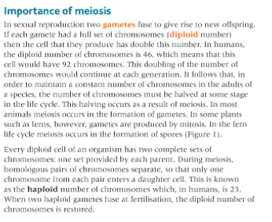
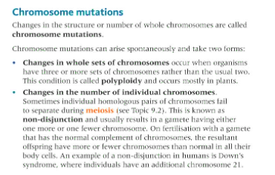
Key facts-
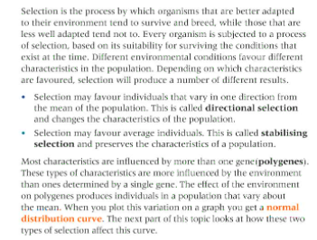

Possible homework tasks I Stretch & challenge (wider reading/independent work)
H/W: including project, Kerboodle, Kahoot, Exam Pro Stretch: modelling tasks, Biological Science Review research, Oxford Uni

