Knowledge organiser for KS5 Biology Homeostasis is the maintenance of a stable internal environment at Saint Ambrose College 2020+
What is covered in this unit?
Principles of homeostasis; importance stable core temperature an blood pH in relation to enzyme activity; importance stable blood glucose concentration in terms of availability of respiratory substrate and water potential of blood; Negative feedback; Control of blood glucose concentration; Role of liver in glycogenesis, glycogenolysis and gluconeogenesis; Action of insulin; Action of glucagon; Role of adrenaline; Second messenger model; Causes of type I and II diabetes; Evaluate positions of health advisers and the food industry to type II diabetes; Control of blood water potential; Osmoregulation; Structure and role of the nephron
Key vocabulary
Gluconeogenesis – the conversion of non-carbohydrate molecules to glucose
Glycogenesis – the conversion of glucose to glycogen
Glycogenolysis – the conversion of glycogen to glucose
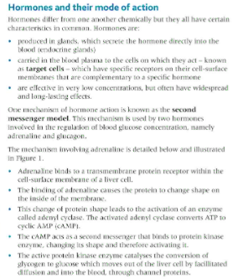
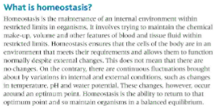
Key facts-
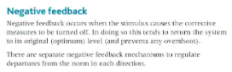

Possible homework tasks I Stretch & challenge (wider reading/independent work)
H/W:including project, Kerboodle, Kahoot. Stretch: modelling tasks, Biological Science Review research.

