Knowledge organiser for KS5 Biology Inheritance at Saint Ambrose College 2020+
What is covered in this unit?
Function of the genotype; Role of the phenotype; Alleles; Diploid organism; Genetic diagrams, monohybrid and dihybrid crosses involving dominant, recessive and codominant alleles, crosses involving sex linkage, autosomal linkage, multiple alleles and epistasis; Chi-squared test
Key vocabulary
Genotype – the genetic constitution of an organism
Phenotype – the observable or biochemical characteristics of an organism
Allele – one of the different forms of a gene
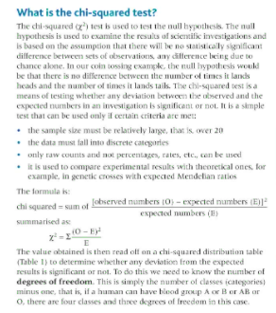
Key facts-
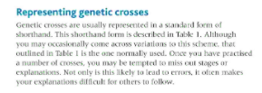
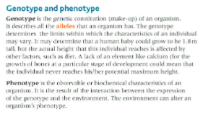

Possible homework tasks I Stretch & challenge (wider reading/independent work)
H/W:including project, Kerboodle, Kahoot. Stretch: modelling tasks, Biological Science Review research.

