Knowledge organiser for KS5 Biology Mass Transport at Saint Ambrose College 2020+
What is covered in this unit?
Haemoglobins, structure, adaptation through possession of different types of haemoglobin; transport of oxygen by haemoglobin, oxyhaemoglobin dissociation curve, oxygen binding, the Bohr effect; circulatory system of a mammal; the structure of the human heart; the cardiac cycle; blood vessels and their functions; transport of water in the xylem; transport of organic molecules in the phloem; investigating transport in plants
Key vocabulary
Primary structure – sequence of amino acids in the four polypeptide chains
Oxygen dissociation curve – the graph of the relationship between the saturation of haemoglobin with oxygen and the partial pressure of oxygen
Cardiac output = heart rate x stroke volume
Transpiration pull – a column of water pulled up the xylem as a result of transpiration
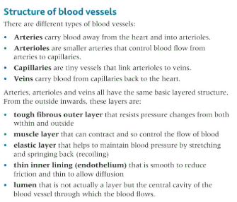
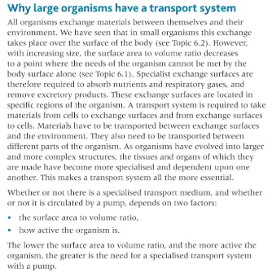
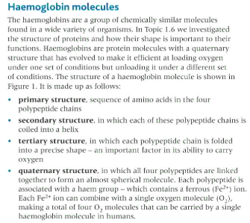
Key facts-

Possible homework tasks I Stretch & challenge (wider reading/independent work)
H/W: including project, Kerboodle, Kahoot, Exam Pro Stretch: modelling tasks, Biological Science Review research, Oxford Uni

