Knowledge organiser for KS5 Biology Nervous Coordination at Saint Ambrose College 2020+
What is covered in this unit?
Structure of myelinated motor neurone; Establishment of resting potential; Changes in membrane permeability; Passage of an action potential; Nature and importance of the refractory period; Factors affecting the speed countenance, myelination and saltatory conduction, axon diameter and temperature; Detailed structure and comparison synapse and neuromuscular junction; Sequence of events in transmission across cholinergic synapse; Effects specific drugs on a synapse
Key vocabulary
Nerve Impulse – a self-propagating wave of electrical activity that travels along the axon membrane
Hormonal system – produces chemicals that are transported in the blood plasma to their target cells
Nervous system – uses nerve cells to pass electrical impulses along their length
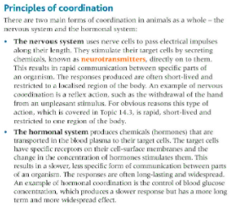
Key facts-
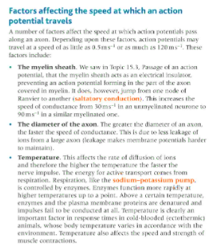
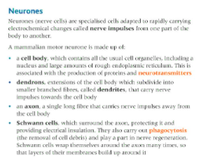

Possible homework tasks I Stretch & challenge (wider reading/independent work)
H/W:including project, Kerboodle, Kahoot. Stretch: modelling tasks, Biological Science Review research.

