Knowledge organiser for KS5 Biology Nucleic Acids at Saint Ambrose College 2020+
What is covered in this unit?
Deoxyribonucleic acid and ribonucleic acid; DNA and RNA; ribosomes; nucleotides; phosphodiester bonds; DNA molecule composition; RNA molecule composition; semi-conservative replication of DNA; adenosine triphosphate; hydrolysis of ATP; resynthesis of ATP; properties of water; inorganic ions
Key vocabulary
Ribonucleic acid – polymer made up of nucleotides
Nuclear division – the process by which the nucleus divides -mitosis and meiosis
Cytokinesis – follows nuclear division and is the process by which the whole cell divides
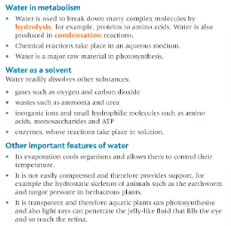
Adenine – a nitrogen-containing organic base
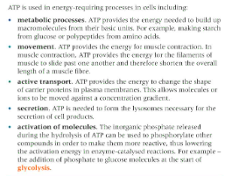
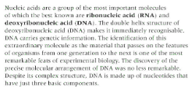
Key facts-

Possible homework tasks I Stretch & challenge (wider reading/independent work)
H/W: including project, Kerboodle, Kahoot, Exam Pro Stretch: modelling tasks, Biological Science Review research, Oxford Uni

