Knowledge organiser for KS5 Biology Nutrient Cycles at Saint Ambrose College 2020+
What is covered in this unit?
Natural ecosystems; Role microorganisms, role of Saprobionts, role of mycorrhizae, role of bacteria; Use of natural and artificial fertilisers; Environmental issues arising from the use of fertilisers
Key vocabulary
Ammonification – the production of ammonia from organic nitrogen-containing compounds
Nitrogen fixation – a process by which nitrogen gas is converted into nitrogen-containing compounds
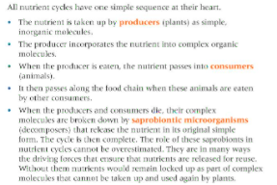
Key facts-
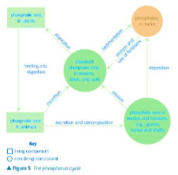
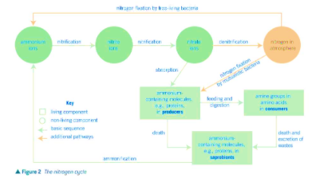

Possible homework tasks I Stretch & challenge (wider reading/independent work)
H/W:including project, Kerboodle, Kahoot. Stretch: modelling tasks, Biological Science Review research.

