Knowledge organiser for KS5 Biology Photosynthesis at Saint Ambrose College 2020+
What is covered in this unit?
Function chlorophyll; energy production; electron transfer; photolysis; reaction carbon dioxide and ribulose biphosphate; reduction GP; use of triose phosphate; environmental factors limit rate; evaluate data relating to common agricultural practices
Key vocabulary
Oxidation – when a substance gains oxygen or loses hydrogen
Reduction – when a substance loses oxygen or gains hydrogen
Photoionisation – when a chlorophyll molecule becomes ionised
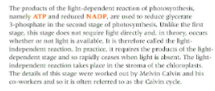
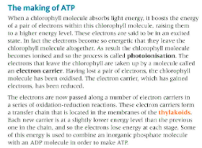
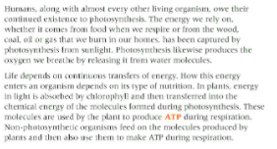
Key facts-

Possible homework tasks I Stretch & challenge (wider reading/independent work)
H/W:including project, Kerboodle, Kahoot. Stretch: modelling tasks, Biological Science Review research.

