Knowledge organiser for KS5 Biology Populations in ecosystems at Saint Ambrose College 2020+
What is covered in this unit?
Communities; Ecosystems; Habitats with both abiotic and biotic conditions; Carrying capacity; Interspecific and intraspecific competition and predation; Size of population; Quadrats; Mark-release-recapture method; Dynamic system; Primary succession; Conservation of habitats
Key vocabulary
Ecology – the study of the inter-relationships between organisms and their environments
Ecosystem – dynamic systems made up of a community and all the non-living factors of its environment
Population – a group of individuals of one species that occupy the same habitat at the same time and are potentially able to interbreed
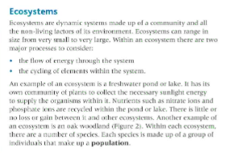
Key facts-
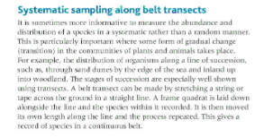
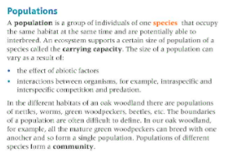

Possible homework tasks I Stretch & challenge (wider reading/independent work)
H/W:including project, Kerboodle, Kahoot. Stretch: modelling tasks, Biological Science Review research.

