Knowledge organiser for KS5 Biology Populations at Saint Ambrose College 2020+
What is covered in this unit?
Species; Populations; Concept gene pool; Concept of allele frequency; Hardy-Weinberg principle and equation
Key vocabulary
Allelic frequency – the number of times an allele occurs within a gene pool
Gene pool – the total number of alleles in a particular population at a specific time
Genotype – the genetic composition of an organism
Phenotype – the characteristics of an organism, often visible, resulting from both its genotype and the effects of its environment
Key facts-
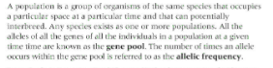

Possible homework tasks I Stretch & challenge (wider reading/independent work)
H/W:including project, Kerboodle, Kahoot. Stretch: modelling tasks, Biological Science Review research.

