Knowledge organiser for KS5 Biology Respiration at Saint Ambrose College 2020+
What is covered in this unit?
Production ATP; Glycolysis; Anaerobic respiration and conversion of pyruvate; Aerobic respiration in detail, link reaction and Krebs cycle, oxidative phosphorylation
Key vocabulary
Aerobic respiration – requires oxygen and produces carbon dioxide, water and much ATP
Anaerobic respiration – takes place in the absence of oxygen and produces lactate in animals or ethanol and carbon dioxide in plants and fungi, but only a little ATP in both cases
Glycolysis – a process by which a hexose sugar, usually glucose, is split into two molecules of the 3-carbon molecule, pyruvate
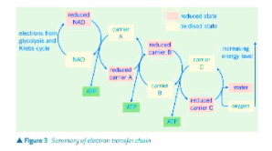
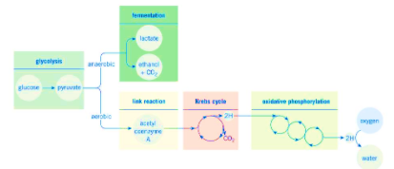
Key facts-
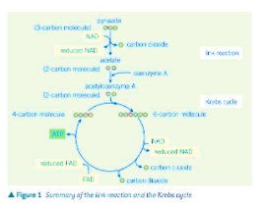
Possible homework tasks I Stretch & challenge (wider reading/independent work)
H/W:including project, Kerboodle, Kahoot. Stretch: modelling tasks, Biological Science Review research.

