Knowledge organiser for KS5 Biology Skeletal muscles are stimulated to contract by nerves and as effectors at Saint Ambrose College 2020+
What is covered in this unit?
Role of muscles; Gross and microscopic structure of skeletal ; Ultrastructure of a myofibril; Roles of actin, myosin, calcium ions and ATP in myofibril contraction; Roles of calcium ions and tropomyosin in cycle of actinomyosin bridge formation; Roles of ATP and phosphocreatine in muscle contraction; Skeletal muscle fibres
Key vocabulary
Actin – filamentous protein which is involved in contraction within cells, especially muscle cells
Myosin – the thick filamentous protein found in skeletal muscle
Sliding filament cycle – this process involves the actin and myosin filaments sliding past one another
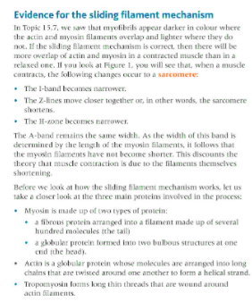
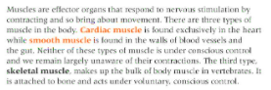
Key facts-
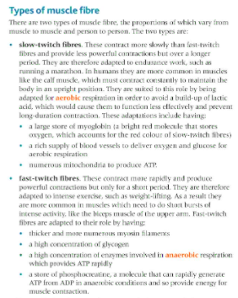

Possible homework tasks I Stretch & challenge (wider reading/independent work)
H/W:including project, Kerboodle, Kahoot. Stretch: modelling tasks, Biological Science Review research.

