Knowledge organiser for KS5 Biology Stimuli at Saint Ambrose College 2020+
What is covered in this unit?
Survival and Response, increase chance survival through changes, specific growth in tissues, different concentrations indoleacetic acid, taxes and kineses, protective effect of simple reflex; Receptors, Pacinian corpuscle as example, deformation stretch-mediated sodium ion channels, the human retina; Control of heart rate, myogenic stimulation, transmission of subsequent wave electrical activity, roles and locations of chemoreceptors and pressure receptors, roles autonomic nervous system
Key vocabulary
Stimulus – a detectable change in the internal or external environment of an organism that leads to a response in the organism
Taxis – simple response whose direction is determined by the direction of the stimulus
Kinesis – a form of response in which the organism does not move toward or away from a stimulus
Tropism – growth of a plant in response to a directional stimulus
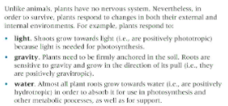
Key facts-
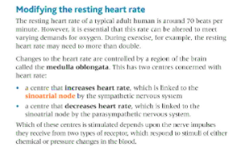
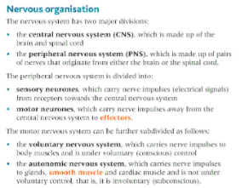

Possible homework tasks I Stretch & challenge (wider reading/independent work)
H/W:including project, Kerboodle, Kahoot. Stretch: modelling tasks, Biological Science Review research.

