Knowledge organiser for KS5 Biology Transport across Cell Membranes at Saint Ambrose College 2020+
What is covered in this unit?
Basic structure of all cell membranes; arrangement and movement of cell contents; cholesterol; cell adaptation; simple diffusion; facilitated diffusion; osmosis; active transport; co-transport
Key vocabulary
Diffusion – the net movement of molecules or ions from a region where they are more highly concentrated to one where their concentration is lower until evenly distributed
Osmosis – the passage of water from a region where it has a higher water potential to a region where it has a lower water potential through a selectively permeable membrane
Active transport – the movement of molecules or ions into or out of cell from a region of lower concentration to a region of higher concentration using ATP and carrier proteins
Plasma membranes – all membranes around and within all cells with the same basic structure
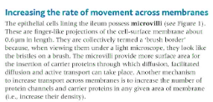
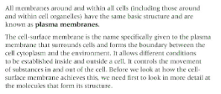
Key facts-
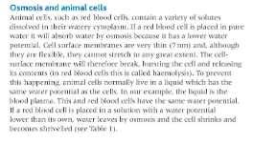

Possible homework tasks I Stretch & challenge (wider reading/independent work)
H/W: including project, Kerboodle, Kahoot, Exam Pro Stretch: modelling tasks, Biological Science Review research, Oxford Uni

