Knowledge organiser for KS5 Biology Using genome projects at Saint Ambrose College 2020+
What is covered in this unit?
Sequencing projects; Proteome and its applications; non-coding DNA and regulatory genes; Sequencing methods
Key vocabulary
Proteome – the proteins the genes code for
Genome – all the genetic information in an organism
Key facts-
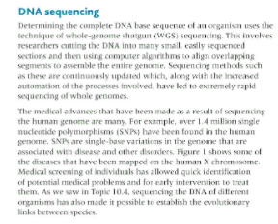
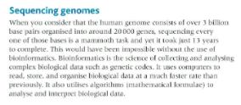
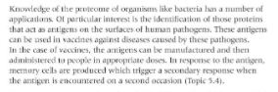

Possible homework tasks I Stretch & challenge (wider reading/independent work)
H/W:including project, Kerboodle, Kahoot. Stretch: modelling tasks, Biological Science Review research.

