Knowledge organiser for KS5 Biology Alterations of the sequence of bases in DNA can alter the structure of proteins at Saint Ambrose College 2020+
What is covered in this unit?
Gene mutations; Mutagenic agents; Different amino acid sequence in encoded polypeptide
Key vocabulary
Gene mutation – any change to one or more nucleotide bases, or any rearrangement of bases, in DNA
Mutagenic agents – basic mutation rate increased by outside factors
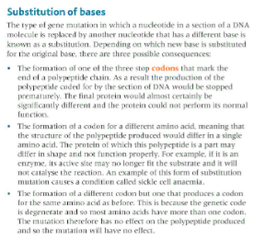
Key facts-
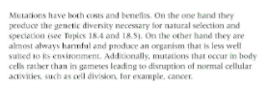
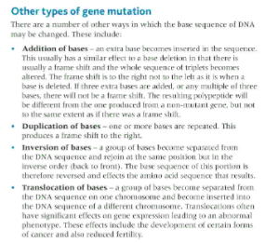

Possible homework tasks I Stretch & challenge (wider reading/independent work)
H/W:including project, Kerboodle, Kahoot. Stretch: modelling tasks, Biological Science Review research.

