Knowledge organiser for KS5 Biology Biodiversity at Saint Ambrose College 2020+
What is covered in this unit?
Species and taxonomy, fertile offspring, role of courtship, phylogenetic classification system, taxa; Diversity within a community, biodiversity, species richness, index of diversity; Species diversity and human activity, farming techniques; Investigating diversity; Quantitative investigations of variation
Key vocabulary
Species – they are capable of breeding to produce living, fertile offspring
Phylogeny – the evolutionary relationship between organisms
Intraspecific variation – where members of the same species differ from each other
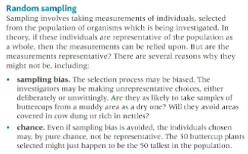
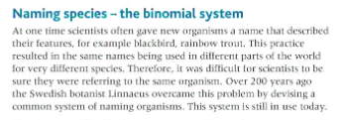
Key facts-
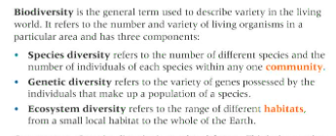

Possible homework tasks I Stretch & challenge (wider reading/independent work)
H/W: including project, Kerboodle, Kahoot, Exam Pro Stretch: modelling tasks, Biological Science Review research, Oxford Uni

