Knowledge organiser for KS5 Biology Biological molecules at Saint Ambrose College 2020+
What is covered in this unit?
Variety of life; monomers; polymers; monosaccharides; condensation reactions; hydrolysis reactions; makeup of glucose; glycosidic bonds; biochemical tests; polysaccharides; basic structure and functions of glycogen, starch and cellulose; triglycerides; phospholipids; fatty acids; R – groups; emulsion test; amino acids; polypeptides; role of hydrogen bonds; ionic bonds and disulfide bridges; variety of function within all living organisms; biuret test; activation energy of enzymes; induced-fit model; specificity of enzymes; rate of enzyme-controlled reactions; types of enzyme inhibitors.
Key vocabulary
Covalent bonding – atoms share a pair of electrons in their outer shell
Hydrogen bonding – the electrons within a molecule are not evenly distributed but tend to spend more time at one position
Monosaccharide – a single monomer
Saturated – all the carbon atoms are linked to the maximum possible number of hydrogen atoms
Activation energy – the minimum amount of energy needed to activate the reaction
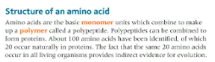
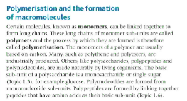
Key facts-
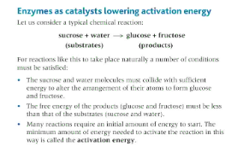

Possible homework tasks I Stretch & challenge (wider reading/independent work)
H/W: including project, Kerboodle, Kahoot, Exam pro Stretch: modelling tasks, Biological Science Review research, Oxford Uni

