Knowledge Organiser
Autumn 1 Half Term Year 7

Topic |  |  |  | Independent Learning and homework tasks
Topic |  |  |  | MyMaths | CorbettMaths.com
Using the correct order of operations, BIDMAS or BODMAS |  |  |  | Algebra/ Expressions and Formulae/ Order of Operations | Number: BODMAS (order of operations) video 211
Rounding numbers to a required degree of accuracy |  |  |  | Number/Estimating and accuracy | Rounding: to whole numbers / to nearest 10 / nearest 100 / to decimal place videos 276-278
Adding, subtracting, multiplying and dividing whole numbers and decimals |  |  |  | Number/Decimals | Decimals: Addition  Decimals: Subtraction  Decimals: Multiplying  Decimals: dividing decimals by integers  Decimals: division by decimals  Videos 90-95
Adding, subtracting, multiplying and dividing with negatives |  |  |  | Number, Counting and Place Value, Negative Numbers 2 | Negatives: addition/subtraction  Negatives: multiplication  Negatives: division  Videos 205-209
Using powers and roots |  |  |  | Number, Powers and Roots, Squares and Cubes | Number: squaring a number/ square root/ cubing a number / cube root  Videos 227 -8, 212-4
Calculating the Mean Median, Mode and Range |  |  |  | Data, Processing Data | Averages: mean / median/ mode / range  Videos 50, 53, 56, 57

Maths Support Attend KS3 Maths Clinic every Friday lunch time for extra help and support.
Stretch and Challenge:
- Practise UKMT Junior Maths Challenge Past papers on:
https://www.ukmt.org.uk/competitions/solo/junior-mathematical-challenge/archive
- Set up an account on parallel.org.uk website, using your school email address and use teacher code “ha52kh”
- Attend Puzzle Club one lunch time each week

Autumns Term 1 Knowledge

Order of operations (BIDMAS)
There is an order to operations:
B (Brackets) - any calculation within a bracket is completed first
I (Indices) – any term with a power is completed second
D (Division) – any division is completed third
M (Multiplication) – any multiplication is completed next
A (Addition) – any addition is completed next in a left to right order
S (Subtraction) – any subtraction is completed last and in a left to right order
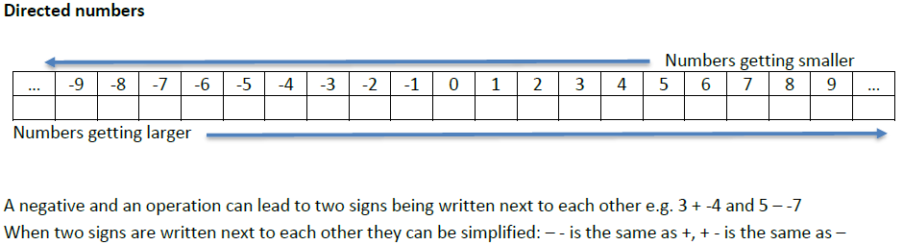

The Decimal Number system
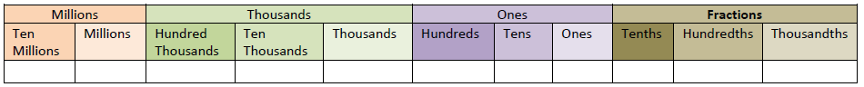

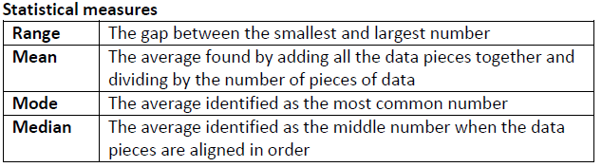


Scan for Full list of Year 7 topics

