Knowledge Organiser
Lent Term Year 7

Topic |  |  |  | Independent learning and homework tasks
Topic |  |  |  | MyMaths | CorbettMaths.com
Properties of quadrilaterals |  |  |  | Shape/2D and 3D shape | 2D & 3D Shapes:  Names/quadrilaterals/nets  /vertices, edges & faces  Videos 1-5
Finding areas and perimeters of rectangles, triangles, parallelograms and trapeziums |  |  |  | Shape/Area of ….rectangles/triangles/a parallelograms/a trapezium | Area:  Parallelogram/rectangle/  Trapezium/triangle  Videos 44, 45, 48 & 49  Perimeter – Video 241
Draw, measure and name angles |  |  |  | Shape/Angles/Measuring Angles | Angles:  Drawing/measuring/types of  Videos 28, 31 & 38
Solving problems involving angles and parallel lines |  |  |  | Shape/Angles/Angles in Parallel lines | Angles: parallel lines (Video 25)
Solving Linear Equations |  |  |  | Algebra/Equations-linear | Equations: solving (Video 110)
Factorising expressions |  |  |  | Algebra/Algebraic Manipulation/Factorising linear | Factorisation (Video 117)
Rearranging formulae (basic) |  |  |  | Algebra/Expressions and Formulae/Rearranging 1 | Algebra:  Changing the subject (Video 7)
Equivalent fractions and cancelling down fractions |  |  |  | Number/Fractions/Equivalent Fractions | Fractions: equivalent (Video 135)
Convert between improper fractions and mixed numbers |  |  |  | Number/Fractions/Improper and Mixed | Fractions:  Improper to mixed/mixed to improper  Videos 139-140
Add and subtract fractions and mixed numbers |  |  |  | Number/Fractions/Adding Subtracting Fractions | Fractions:  Addition same denom /addition different denom  Videos 132-133
Multiply and divide fractions |  |  |  | Number/Fractions/Multiply Divide Fractions | Fractions:  Division/multiplication  Videos 134 & 142
Construct and interpret statistical diagrams including pictograms, bar charts, line graphs, pie charts, frequency polygons |  |  |  | Data/Presenting Data/… | Graphs:  Bar charts/line graphs/pictograms/pie charts/frequency polygons  Videos – 147,148,155,156, 160-164

Stretch and Challenge:
- Practise UKMT Junior Maths Challenge Past papers on:
https://www.ukmt.org.uk/competitions/solo/junior-mathematical-challenge/archive
- Set up an account on parallel.org.uk website, using your school email address and use teacher code “ha52kh”

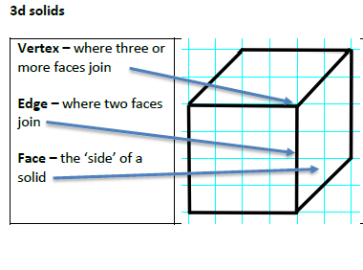
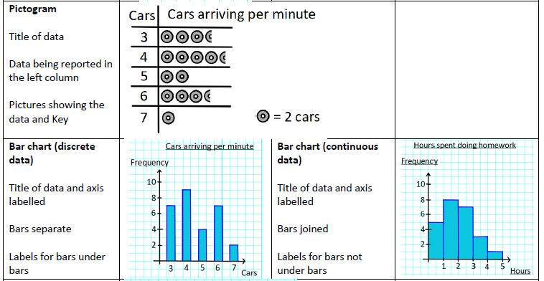
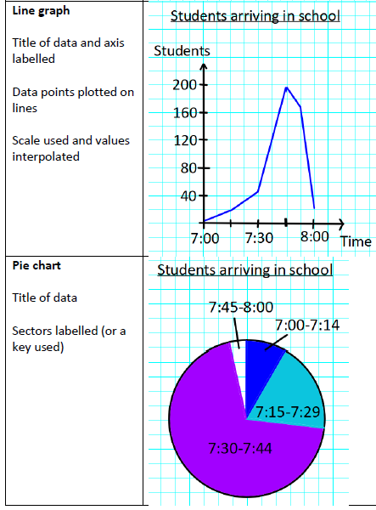
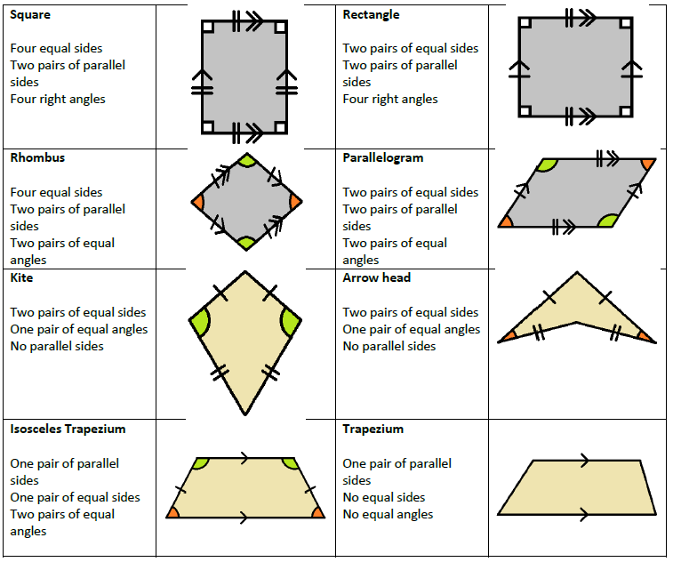
Lent Term Knowledge

Scan for full list of Year 7 topics

