Knowledge Organiser
Trinity Term Year 7
Topic |  |  |  | Independent learning and homework tasks
Topic |  |  |  | MyMaths | CorbettMaths.com
Circles – find the circumference and area |  |  |  | Shape/Area and perimeter | Circles – area/circumference (Videos 59-60)
Angles in polygons – including interior and exterior |  |  |  | Shape/Angles | Angles – polygons (Video 32)
Convert between fractions, decimals and percentages |  |  |  | Number/Fractions | FDP – (Videos 121–131)
Percentages of amounts |  |  |  | Number/Percentages | Percentages – of an amount (Videos 234-235)
Ratio and proportion (unitary method) |  |  |  | Number/Ratio and proportion | Ratio (Videos 269-271a)  Proportion – unitary method (Video 255a)
Sequences |  |  |  | Algebra/Sequences | Sequences – describing rules (Video 286), nth term (Video 288)
Recognising other sequences (Fibonacci, triangular, square etc) |  |  |  | Algebra/Sequences | Sequences – Fibonacci (Video 287a), patterns (Video 290)
Arithmetic and geometric sequences |  |  |  | Algebra/Sequences | Arithmetic progressions, geometric progressions (Videos 374-375)
Basic probability |  |  |  | Data/Probability | Probability – basic (Video 245)
Probability – including mutually exclusive, experimental and theoretical |  |  |  | Data/Probability | Probability – OR rule, conditional, independent (Videos 244-250)
Sample space diagrams (two-way tables) |  |  |  | Data/Collecting data | Probability – sample space (Video 246), listing outcomes (Video 253)
Set notation and Venn diagrams |  |  |  | Data/Probability | Set notation, Venn diagrams (Videos 379-380)
Probability – using frequency trees |  |  |  | Data/Probability | Probability – tree diagrams (Video 252)
Stretch and Challenge:
- Practise UKMT Junior Maths Challenge Past papers on:
https://www.ukmt.org.uk/competitions/solo/junior-mathematical-challenge/archive
- Set up an account on parallel.org.uk website, using your school email address and use teacher code “ha52kh”
Trinity Term Knowledge
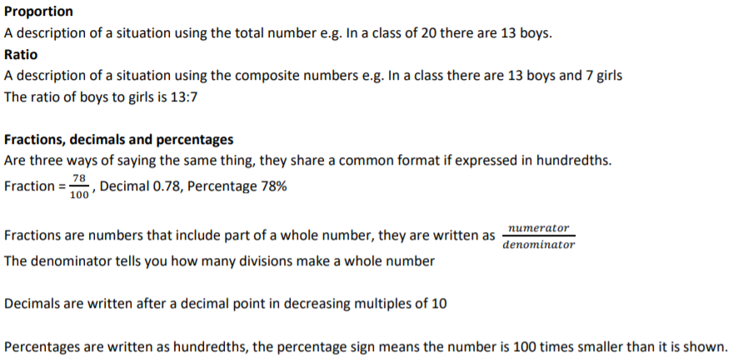

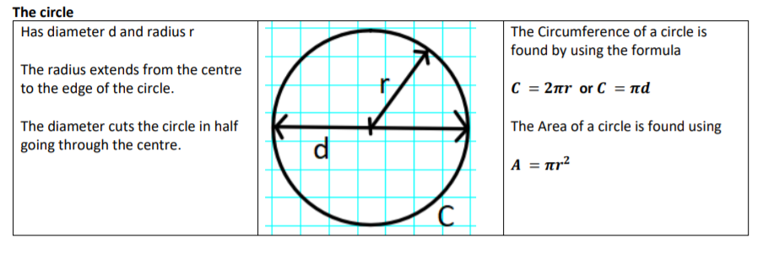

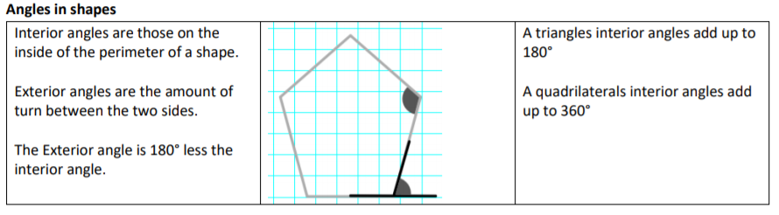

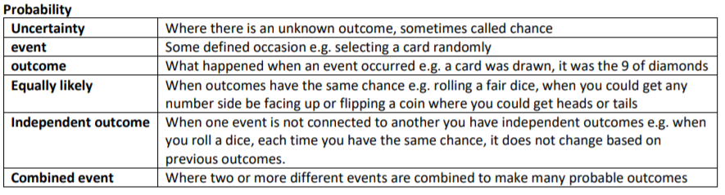


Scan for full list of Year 7 topics

