
GCSE Physical Education Paper 2 Section 4
Knowledge Organiser

R | I am not confident with this work  I am completely unsure what to do next  I have tried to find help independently using the text book and internet but still need help
A | I am almost confident with this work  I need to clarify exactly what to do next  I have tried seeking additional help, but would like further advice
G | I am confident with this work  I know what I need to do next  I have all the additional help I need

Ref: | Paper 2 Topics | Covered | R | A | G
P83 | Chapter 4: Sports psychology
P84-87 | Skill and ability
P88-89 | Goals and targets
P90-91 | Information Processing
P92 | Guidance and feedback on performance
P93-100 | Arousal
P101 | Aggression
P102 | Personality types
P103 | Motivation

Chapter 4 Sports Psychology

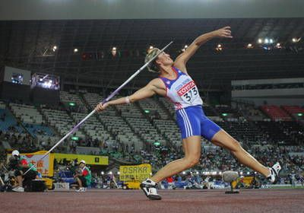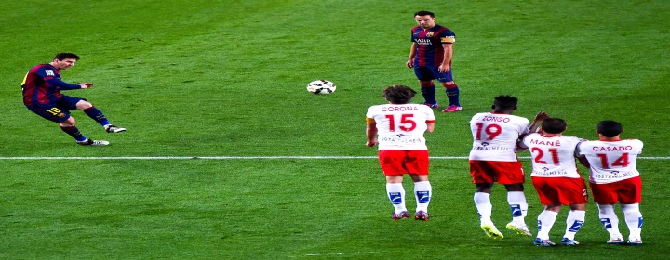
Ref no. | A01 Key Term | Definition
1.  2.  3.  4.  5.  6.  7.  8.  9.  10.  11.  12.  13.  14.  15.  16.  17.  18.  19.  20.  21  22.  23.  24.  25.  26.  27.  28.  29.  30.  31.  32.  33.  34.  35.  36.  37.  38. | Skill  Ability  Basic skill  Complex skill  Open skill  Closed skill  Self paced skill  Externally-paced skill  Gross skill  Fine skill  Performance goal  Outcome goal  SMART  Information  Processing  Intrinsic feedback  Extrinsic feedback  Guidance  Visual guidance  Verbal guidance  Manual guidance  Mechanical guidance  Feedback  Knowledge of results  Knowledge of performance  Intrinsic feedback  Extrinsic feedback  Arousal  Deep breathing  Mental rehearsal  Positive self-talk  Aggression  Direct aggression  Indirect aggression  Introvert  Extrovert  Motivation  Intrinsic motivation  Extrinsic motivation | A learned behavior / action to bring about a predetermined result.  An inherited trait that determines an individual’s potential.  A simple skill that does not require much concentration.  A skill that requires a great deal of concentration and coordination.  A skill which is performed in a certain way to deal with a changing or unstable environment.  A skill which is not affected by the environment or performers.  A skill that is started when the performer decides to start it.  The skill is started because of an external factor.  A skill that uses big movements and large muscles.  A skill that uses small movements and smaller muscles.  A goal where there is no comparison with other performers.  A goal that will focus on the end result, such as winning.  Target setting that is Specific, Measurable, Accepted, Realistic and Time-bound.  A model used for making decisions which includes Input, Decision making, Output and Feedback.  Information a performer receives from within.  Information a performer receives about their performance from outside themselves, such as from a coach.  A method of conveying information to a performer.  Guidance that you can see, such as a demonstration.  Guidance that is provided by another person speaking to you.  Guidance that physically involves the performer.  Guidance that uses mechanical aids to assist a performer.  Information a performer receives about their performance.  Feedback about the outcome.  Feedback about the quality of performance, such as technique.  Feedback from within, for example kinesthetic feel.  Feedback from an external source.  A physical and mental state of alertness/readiness.  Taking slow, deep breaths whilst relaxed.  Use of visualization /imagery involving the control of mental thoughts.  A relaxation technique aimed at developing positive thoughts about your performance.  Can be classified as direct or indirect.  An aggressive act that involves physical contact with others.  An aggressive act that does not involve direct physical contact.  A quiet, shy, passive and reserved personality type.  A social, active talkative and outgoing personality type.  The drive to succeed or the desire to achieve or be inspired.  The drive to succeed that comes from within.  The drive to perform well or to win in order to gain external rewards.

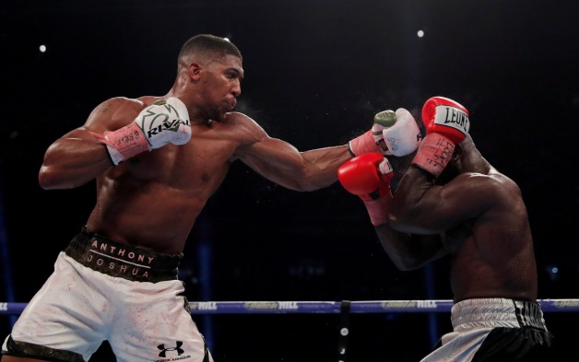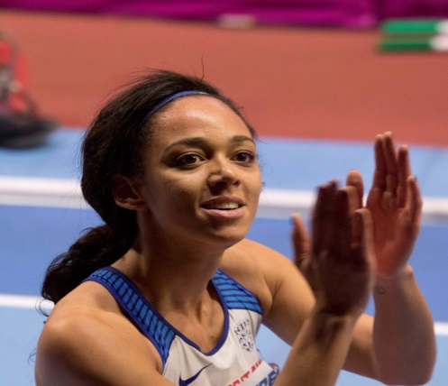
Ref no. | A02 / A03 Progress Check and Examination practice –Formative | Marks
1.  2.  3.  4.  5.  6.  7.  8.  9  10.  11.  12.  13.  14.  15.  16.  17. | What is the difference between a skill and an ability?  Classify the following skills as either open or closed. For each classification, explain why you have made your choice.  - A shot during football during open play  - A pass / setting in Volleyball  - A forward roll in Gymnastics  - A high Jump  - A goalkeeper trying to save a penalty flick in hockey.  Classify a javelin throw as either a gross or fine skill. Justify your answer.  Complete the table below to show what performance and outcome goals could be set for the badminton beginner and elite javelin thrower?  What do you understand by the term ‘selective attention’?  Explain the ‘input’ stage of information processing.  For the beginner in the sport of basketball, how might visual, verbal and manual/mechanical guidance be provided?  What type of guidance is most important for beginners?  Why should negative feedback not be used excessively with beginners?  A beginner new to the sport requires feedback on their attempt at hitting a hockey ball. Should Knowledge of Results or Knowledge of Performance be given? Justify your answer  Explain how arousal affects performance according to the Inverted U theory.  Name a mental/cognitive technique that could be used to control arousal.  If a sports performer was suffering from over arousal, name and explain a somatic technique that could be used to control their level of arousal.  Which one of the following tends to describe an introvert personality?  - easily excited  - enjoys sociable occasions  - usually shy  - very talkative  What do you understand by the term motivation?  What is the difference between intrinsic and extrinsic motivation?  Is intrinsic or extrinsic motivation generally regarded as the most beneficial? Explain your answer? | 2  10  2  4  1  2  3  1  1  4  3  1  2  1  1  2  2

Ref no. | A02 / A03 Progress Check and Examination practice – Stretch and challenge. | Marks
1.  2.  3. | A 6 and/or 9 marks question can be set by your subject teacher.  Zig Zag Topic Test  Exampro Sports Psychology Topic Test | 6 or 9  26 marks

