
GCSE Physical Education Paper 2 Section 5
Knowledge Organiser

R | I am not confident with this work  I am completely unsure what to do next  I have tried to find help independently using the text book and internet but still need help
A | I am almost confident with this work  I need to clarify exactly what to do next  I have tried seeking additional help, but would like further advice
G | I am confident with this work  I know what I need to do next  I have all the additional help I need

P105 | Chapter 5: Socio-cultural influences
P106 | Social groups and factors affecting participation
P107-121 | The commercialization of physical activity and sport
P122-123 | The impact of technology on physical activity and sport
P124-129 | Ethical conduct by performers
P130-131 | Spectator behaviour

Chapter 5 Socio-cultural influences
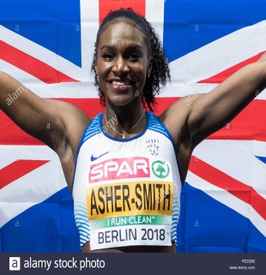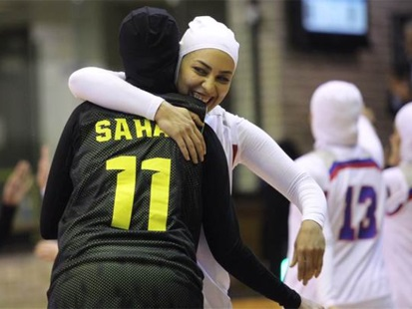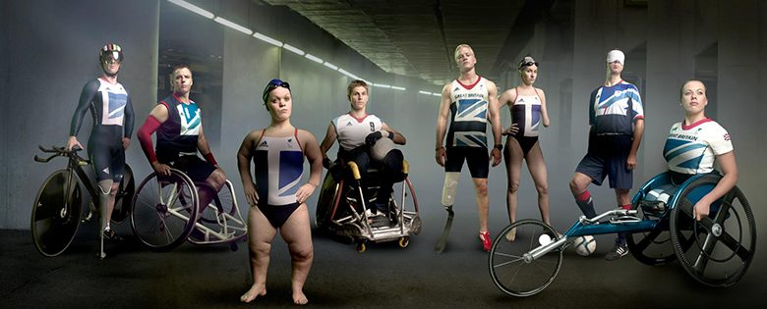
Ref no. | A01 Key Term | Definition
1.  2.  3.  4.  5.  6.  7.  8.  9.  10.  11.  12. | Social groups  Stereotype  Barrier to participation  Ethnic group  Socio-economic group  Role model  Peer group  Disability  Adapted sport  Discrimination  Prejudice  Inclusive | People who interact with one another, share similar characteristics.  Widely held but fixed and oversimplified idea of a particular type of person.  An obstacle that prevents a group within society from participating in sport or physical activity.  A community made up of people who share a common cultural background.  A group’s place within society; depends of different factors including occupation, education, income, wealth and where they live.  A person looked up to by others as example to be copied.  A group of people of approximately the same age, status and interests.  A physical or mental condition that limit’s a person’s movements, senses or activities.  Competitive sports for individuals with disabilities.  The unjust or prejudicial treatment of different groups of people, especially on the grounds of race, age and gender.  Preconceived opinion that is not based on reason or actual experience.  Including everybody.

Ref no. | A02 / A03 Progress Check – Formative assessment | Marks
1.  2.  3.  4. | Discuss whether the opportunities for women to take part in sport and physical activity are the same as for men.  Give three reasons for the lower participation rates among some ethnic minority groups.  The participation of women in physical activities is often dependent upon the opportunities available to them.  Explain the term discrimination.  What is meant by the terms stereotyping and inclusiveness? | 4  3  2  2

Chapter 5 Commercialisation of physical activity and sport
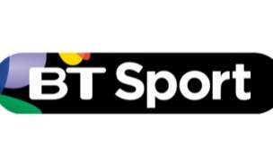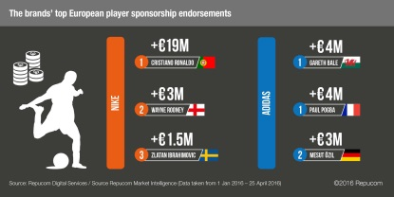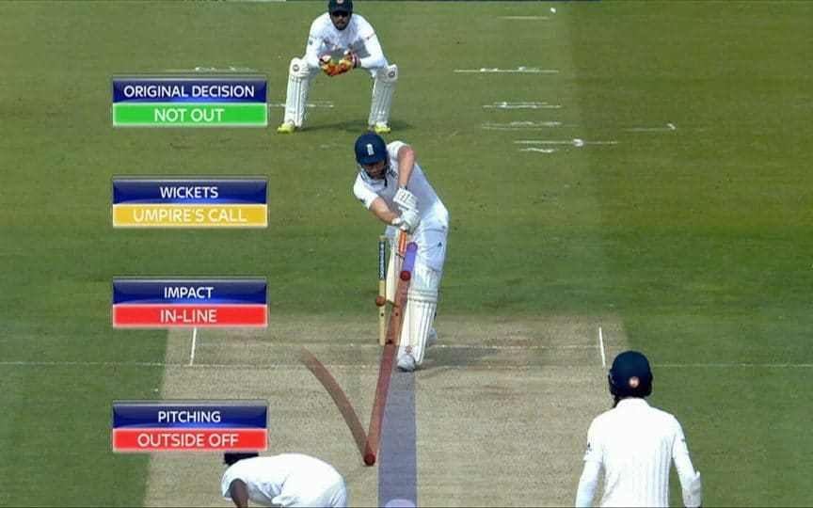
Ref no. | A01 Key Term | Definition
1.  2.  3.  4.  5.  6.  7.  8.  9.  10.  11. | Commercialisation  Media  Sponsorship  Golden Triangle  Spectators  Marketability  Technology  Hawkeye  TMO  VAR  Match Analysis | The process by which a new product or service is introduced into the general market.  The main ways that people communicate collectively through television, radio, newspapers and social media.  Provision of funds or other forms of support to an event, activity, person or organization in return for some kind of commercial return.  The financial relationship between sport, sponsorship and media.  People who watch sport, can be at the event or watch/listening/reading – ‘armchair spectating’.  Able to be sold.  A method that is developed to try and improve performance.  An optical ball-tracking device used as an aid to officiating in tennis and cricket.  Television match official used in rugby union to make decisions using replays of incidents.  Video assisted referee used in football to assist the awarding / disallowing of goals.  Computer software that provides statistical data about individual and/or team performances.

Ref no. | A02 / A03 Progress Check – Formative assessment | Marks
1.  2.  3.  4.  5. | In commercialised sport, how does the ‘golden triangle’ work?  What are the advantages and disadvantages of this golden triangle?  What are the disadvantages to a sport of increased media control?  In what ways has an increase in the ‘commercialisation’ of sport been beneficial for performers and the sport?  Suggest, using specific examples, how the increased use the technology has helped officials to make the correct decision. | 4  4  4  4  4

Chapter 5 Ethical Issues
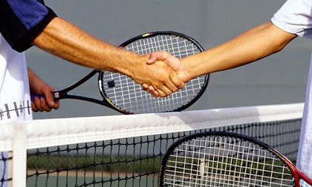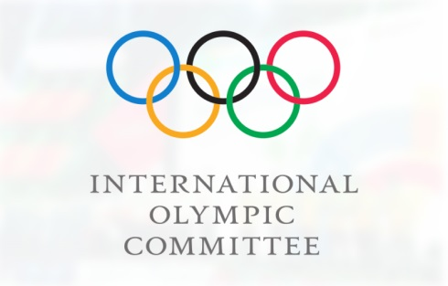
Ref no. | A01 Key Term | Definition
1.  2.  3.  4.  5.  6.  7.  8.  9.  10.  11.  12.  13.  14.  15.  16.  16.  17. | Etiquette  Sportsmanship  Gamesmanship  Contract to compete.  NGB  IOC  Ergogenic aid  PEDs  Stimulants  Narcotics  Anabolics  Peptide – EPO  Blood doping  Diuretics  Viscosity  Beta blockers  Home field advantage  Hooliganism | An unwritten rule concerning correct player behavior.  Conforming to the rules, spirit and etiquette of the sport.  Attempting to gain an advantage by stretching the rules to their limit.  An unwritten agreement between opponents to follow and abide by the written and unwritten rules of the sport.  National Governing body such as the Football Association who are responsible for managing their specific sport.  International Olympic Committee, who organise the Olympic Games.  A substance used for the purpose of enhancing performance.  Performing enhancing drugs.  Make athletes alert and mask the effects of fatigue.  Painkillers that mask pain caused by injury or fatigue.  Drugs that help athletes to train harder and build muscle.  Increases numbers of red blood cells and therefore improves oxygen delivery to working muscles.  Artificially increasing the number of red blood cells.  Drugs that remove fluid from the body.  How ‘thick’ a liquid is.  Drugs taken to calm performer down by reducing effects of adrenaline  The psychological advantage that the home team has over the visiting team as a result of playing in their own stadium.  The disorderly, aggressive behavior by spectators at sporting events.

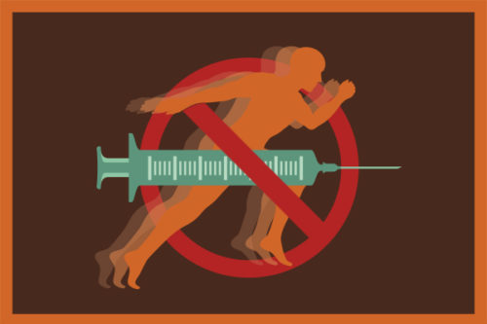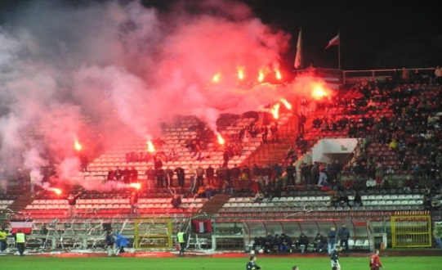
Ref no. | A02 / A03 Progress Check – Formative assessment | Marks
1.  2.  3.  4.  5.  6.  i.  ii. | Is diving in Football gamesmanship or bad sportsmanship?  Justify your answer.  How is the ethic of sportsmanship encouraged and maintained at the highest level of sport?  Taking EPO is a form of blood doping. What are the supposed benefits of this practice and what type of performer might take EPO?  Suggest why a performer might take anabolic agents?  Some performers may take PEDs to improve performance. Suggest two potential advantages and two disadvantages of a performer taking PEDs.  Hooliganism at football matches, both inside and outside stadiums, is a recurring problem.  Describe three steps that have been taken to prevent such acts.  Identify three reasons that have been suggested as to why football should suffer from hooliganism. | 3  2  3  2  4  3  3  (6)

Ref no. | A02 / A03 Progress Check – Summative assessment/Stretch and challenge | Marks
1.  2.  3. | A 6 and/or 9 marks question can be set by your subject teacher.  Zig Zag Topic Test  Exampro Socio-cultural Topic Test | 6 or 9 marks  27 marks

